
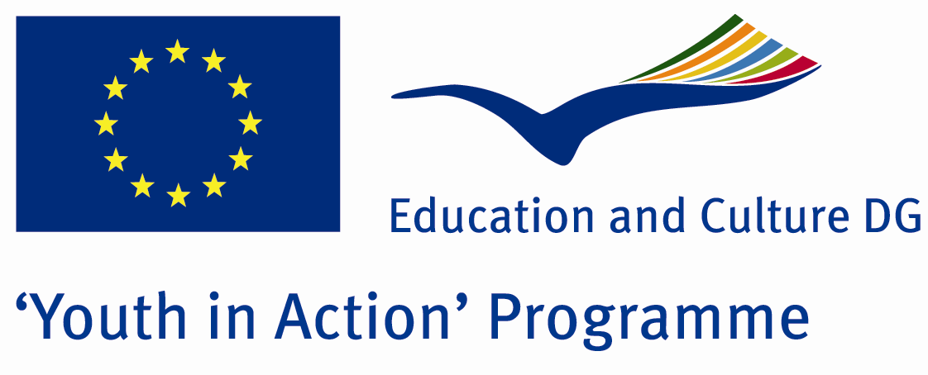

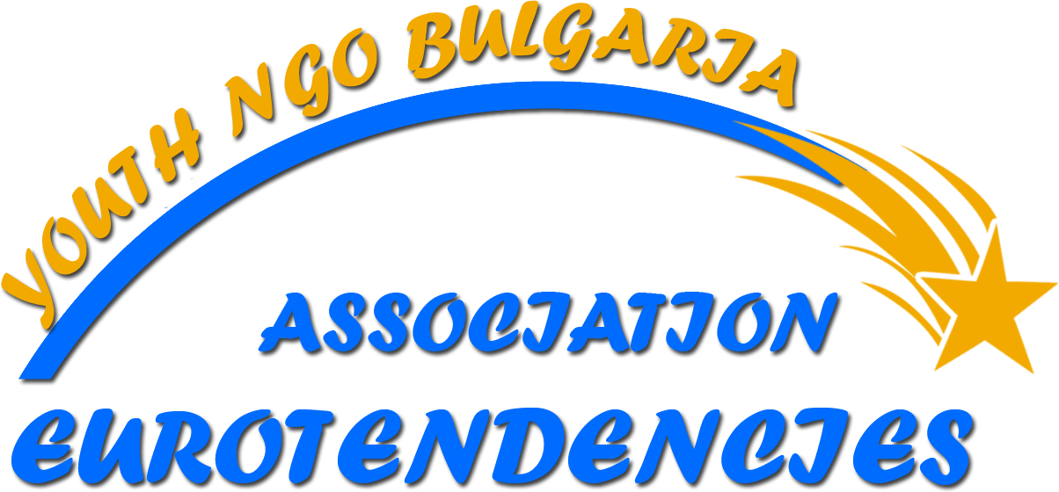

“THE EUROPEAN VISION – FACE OF THE YOUTH PEOPLE”
YOUTH EXCHANGE 06 – 19 APRIL 2010
PRELIMINARY PROGRAM* OF THE ACTIVITIES

day | Morning time zone |  | Afternoon time zone |  |  | Evening time zone
day | 8-10 | 10-12 | 12-15 |  | 15-18 | 18-20 | 20 +
06 April  Tuesday | Arriving and accommodation of the participants in Veliko Tarnovo;  Common Dinner;  „You are already in Bulgaria” – party by way of welcome with getting to know character;
07 April  Wednesday | Breakfast;  Sport activities;  Filling in the work sheets with opinions and impressions from the past day; | „Who is who?” – a role game for getting to know the groups;  „Granny is watching you…” – a role game for ice-breaking;  „My fears and expectations about the youth exchange” – the youth are put in conditions of simulated environment; | Common Lunch;  Break time;  „Substance and meaning of anti-discriminatory campaigns and projects” – discussion; | „Be a Human” – workshop meant to prepare the participants for realization of the campaigns with anti-discriminatory character;  „Plane Wreck Game” – a role game with the purpose of taking an important decisions in the groups; |  | Common Dinner;  Preparation for the intercultural evening; | Intercultural evening – demonstrations of typical for the other countries dances, discussions in informal atmosphere, songs etc.
08 April  Thursday | Breakfast;  Sport activities;  Filling in the work sheets with opinions and impressions from the past day; | „Be a Human” – realization of the campaign with anti-discriminatory character among the youth in Veliko Tarnovo; | Common Lunch;  Break time;  „What change me from yesterday till today?” – workshop working in small groups; | „Two truths and a lie” – a role game for making a good teams and encouragement the free thinking;  „What do you know about Bulgaria?” – discussion meant to introduce to our guests the characteristics of our country and its place in the European Union; |  | Common Dinner;  Preparation for visiting the show-spectacle „Light and Sound”; | Visiting of the show-spectacle  „Light and Sound” – part of our nation heritage, which is a basic element in building the United Europe;
day | Morning time zone |  | Afternoon time zone |  |  | Evening time zone
day | 8-10 | 10-12 | 12-15 | 15-18 |  | 18-20 | 20+
09 April  Friday | Breakfast;  Sport activities;  Filling in the work sheets with opinions and impressions from the past day; | “Pulse” – a role game to check the level of preparation of the students;  “Who’s the killer” – a role game for refreshing of the working environment;  “Meaning of democracy and the freedom to choose the future of the young people” – discussion and presentations; | Common Lunch;  Break time;  “I change you, you change them, they change Europe” - workshop;  Tell us about Europe through your eyes’ – short presentation of the comprehension and explanation of the idea of the United European Community; | “How the elders accept the youth?” – work in groups with moderators;  “SWOT analysis of the youth politics of every country of the presented” – work in small groups and presenting of the results; |  | Common Dinner;  “Hopes and fears” – a role game for an end of the work day; | “Tolerance and solidarity – can we go on without them?” – discussion;  Free time;
10 April  Saturday | Breakfast;  Sport activities;  Filling in the work sheets with opinions and impressions from the past day; | “Let’s make a charter for one steady development” – workshop;  “Ecology – a building element of the steady development” – discussion and sharing of good practices; | Common Lunch;  Break time;  Preparation for the eco campaign “Keep our town clean”; | “Keep our town clean” – eco campaign in the area of Ksilifor (ecology as a building element of the steady development); |  | Common Dinner;  “Opposite a sheet of paper” – a role game for ice-breaking and predisposing to communicating in an informal atmosphere; | Free time;
11 April  Sunday | Breakfast;  Sport activities;  Filling in the work sheets with opinions and impressions from the past day; | “Simon says…” – a role game for refreshing and entering of the participants in the working environment;  “Introducing of the activity, the members and the good practices of Association “Eurotendencies” – visualization and carrying into practice; | Common Lunch;  Break time;  “Introducing of the activity, the members and the good practices of guest 1” – visualization and carrying into practice; | “Introducing of the activity, the members and the good practices of guest 2” – visualization and carrying into practice;  “Introducing of the activity, the members and the good practices of guest 3” – visualization and carrying into practice; |  | Common Dinner;  “For and against globalization” – debate between the participants defending the different positions; | “For and against globalization” – debate between the participants defending the different positions;  Free time;
day | Morning time zone |  | Afternoon time zone |  |  | Evening time zone
day | 8-10 | 10-12 | 12-15 | 15-18 |  | 18-20 | 20+
12 April  Monday | Breakfast;  Sport activities;  Filling in the work sheets with opinions and impressions from the past day; | A formal reception in Municipality Veliko Tarnovo;  An official press conference for the leaders and organizers of the project(the participants are also there); | Common Lunch;  Presentation of the Veliko Tarnovo’s university „St. St. Cyril and Methodius” with a lecture about: „With European self-consciousness for the security and development of the community”; | Break time;  „We are the European committee” – the participants are put in conditions of simulated environment, like in this way analytical, logical, suggestive and practical workable thinking are provoked; |  | Common Dinner;  „Over and Under” – a role game for breaking the formal atmosphere; | „Let us be different” – the participants are put in conditions of simulated environment, like the idea is the youth to present the fields, in which the people are different and to encourage the understanding and accepting the people, who are different from us;
13 April Tuesday | Breakfast;  Filling in the work sheets with opinions and impressions from the past day; | „Welcome my friend” – after filling in the work sheets the youth from Bulgaria will receive in their homes two or three participants from our partner countries. In this day the hosts will introduce to their new friends their daily activities, their family and friends and if it is possible, they will visit the schools, in which the Bulgarian youths are learning. The evening, every Bulgarian family will spare the necessary time for communicating with the guests in informal atmosphere;
14 April Wednesday | „Hand-in-hand and after the project” – the visiting in the Bulgarian family continue through the whole day, like the main activity between the youth is to find a common interests, interesting themes for talking, occasions in their free time etc. The expected result is making lasting friendships between the participants and after the youth exchange, relying each other on their friendships, hospitality and visiting the other.The work is in home circumstances, like having in mind that the groups are between 3-5 participants, and presentation of the results will be realized in the last day of the project. For this day the system for inwardly communication and correspondence of Association “Eurotendencies” will work and this way excepting the home circumstances, the participants will have the opportunity for working in the web through internet with the other participants in the project, as well as with other youth boys and girls from the partner countries.
15 April  Thursday | Departure, arriving and accommodation of the participants in  LB „Panorama” resort complex Pamporovo;  Common Lunch during the way (dry packet); |  |  | „Substance, particularities and meaning of the civilian community in guest 1” – discussion between the participants; |  | Common Dinner;  „You already know us – are you sure?” – presentation of our guest country number 1; | Traditional intercultural evening, devoted to our guest 1 (songs, dances, games, communication);
16 April  Friday | Breakfast;  Sport activities;  continue on the next page | „Fast, brave, skilful” – competition with pulling a rope, jumping with sacks, relay games etc. – sport like a part for healthy way of life; | Common Lunch;  Break time;  continue on the next page | „Substance, particularities and meaning of the civilian community in guest 2” – discussion between the participants;  continue on the next page |  | Common Dinner;  „You already know us – are you sure?” –  presentation of our guest country number 2; | Traditional intercultural evening, devoted to our guest 2 (songs, dances, games, communication);
day | Morning |  | Afternoon |  |  | Evening
day | 8-10 | 10-12 | 12-15 | 15-18 |  | 18-20 | 20+
16 April  Friday | Filling in the work sheets with opinions and impressions from the past day; | Look at the previous page | „Crossover projects” – brainstorming for analyzing the knowledge of the youth about „crossing” projects in different programs; | „Fruit Salad” – a role game for predisposition of the participants about the intercultural evening. |  | Look at the previous page | Look at the previous page
17 April  Saturday | Breakfast;  Sport activities;  Filling in the work sheets with opinions and impressions from the past day; | „Face of the young people in Europe – who form it and how?” – debate between the youth, who assert different positions; | Common Lunch;  „Problem – Decision” –brainstorming for the participants connected with themes about youth in disadvantaged position; | „Substance, particularities and meaning of the civilian community in guest 3” – discussion between the participants; |  | Common Dinner;  „You already know us – are you sure?” –  presentation of our guest country number 3; | Traditional intercultural evening, devoted to our guest 3 (songs, dances, games, communication);
18 April  Sunday | Breakfast;  Sport activities;  Filling in the work sheets with opinions and impressions from the past day; | „Compass” – simulated game for orientation and team work; | Common Lunch;  „Let us lay the foundations of future co-operation between us” – workshop, in which the youth and the leaders discuss ideas for future projects; | „Substance, particularities and meaning of the civilian community in Bulgaria” – discussion between the participants; |  | Common Dinner;  Presentation of the group’s results from the activities in the home atmosphere „Hand-in-hand and after the project”; | Traditional intercultural evening, devoted to Bulgaria (songs, dances, games, communication);  „Till new meetings” –festive evening with a lot of games, dances and surprises for the participants;
19 April  Monday | Departure for Sofia and dispatch the guests.

* The program can be changed according to the number of the partner countries.

