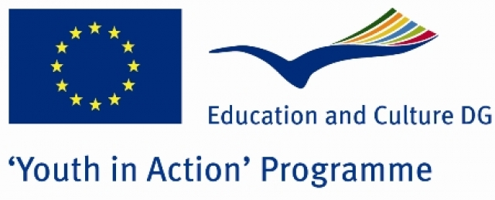
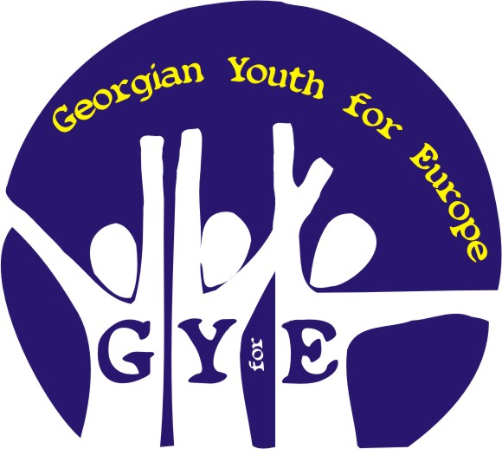

CALL FOR PARTNERS

„ MY CHILDHOOD GARDEN„

Action 3.1. Youth Exchange
Cooperation with Neighbouring Partner Countries

2010

Objective, Context and Motivation

„Childhood in our countries” is innovative, youth exchange project about life problems – young persons and young parents unemployment, their and their kids social inclusion in local society. 25 young people aged 19-25 from four countries (Europe, South East Europe and Caucasus) will came together and discuss parents atitude about their children, the role of families’ social and economical situation and how it makes influence on their integration in local society, and ofcourse about the diferent ways how to grow up our children. In each country’s group will be one phsicologist or a participant who is able to talk about their countries’ young, unemployed parents and their children problems. The trainings and workshops will cover the tasks about parents unemployment and its role in their social life,whether it makes any differences and wheather it influences on family life, social inclusion in local society and children personal development or not.

The youth in South East Europe and Caucasus do not have many opportunities to take an active role in raising public awareness about young people unemployment and social poorness. There exists many problems in these regions for young, unemployment parents and their children.Young people with an unemployed parents have a grater chance of experiencing homelessness,suffering from child abuse,failing to complete high school or college and living in a poverty. And we are motivated to exchange social experience between Europe and not so developed regions (for example Georgia) and to gain, exchange much more information and exparience about this case.

During project time we are going to visit a kindergarten and to talk with the target group- children age of 1 to 6 and their parents. After that the participants will be able to have discassion and to find out the solutions how to solve and get over lot of social problems what is connected with young parents unemployment and their attitute and treatment with their children.

Participants will have trainings, discussions, workshops and main result – booklets. there will be articles in the booklets prepared by each country about young family unemployment, their and their kids social barriers, information and motivation about right atittude and normal relationship between children and parents in each country. Each countries group will be asked to make homework. Homework will be the interviw with the young unemployed paents which live in their city. Participants will be asked to take and collect some interesting pictures of young families before the exchange.
Each participant group after youth exchange will spread these booklets in their countries for the people in the street.

Activities

- Participants get to know each other, presentations, team building activities.
- Trainings and activities – to inform about childhood, young, unemployment parents problems in each countries and about relationship between this social group parent and their child. The trainings and workshops will cover the tasks about parents unemployment and its role in their social life,whether it makes any differences and whether it influences on family life, social inclusion in local society and children personal development or not.
- Visiting the kindergarten - getting exparience while talking with the children, their parents and to find out they needs, problems etc.
- Preparation of the project results and their processing - Booklet making and their spreading in the streets in each country.
- Project’s conclusion evening – talk about what this project meant to the people who was involved in it and realize what is to be done to settle the problems.

Target Group
Participants - youngsters of different genders, ages (19-30), nationalities and backgrounds who are interested in making families in the future or have it already, who cames from different social groups and working with the children. Also they are interested in article writing, performances making and realisation, with different level of experience in various ways of creative initiatives. They are interested in issues of youth phsicology – young people economical problems (unemployment) - and they have a wish to work in international team and in the creative way .

Funding
70% of travel costs, 100% of food and lodging costs and exceptional costs such as actual costs covering visa, visa-related costs and vaccination costs, as well as costs related to participants with fewer opportunities/special needs will be covered.

Partners
All Youth in Action Program countries.
Firstly we are searching motivated NGO which could help us to submit our ready project!As the project will be applied to the Youth in Action Programme, we kindly ask you to send us your singed and stamped Part III via email to tkoch09@feeuni.edu.ge

Contact
Tamar Kochiashvili
(Project Manager)
Tkoch09@freeuni.edu.ge; georgianyouth@gmail.com
+99555123301
Association “Georgian Youth for Europe”



_______________________________________________________________

