European Voluntary Service (EVS)

What We Do:
Projects around the world receive funding from the EU each year under Youth In Action grants. These grants are applied to a variety of projects designed to offer young Europeans the chance to make a real difference in the world around them. Including EVS opportunities, these types of projects range from those in the environmental and agricultural sector to activities with children, disadvantaged youth, the elderly, and even the disabled.
Code-X International is an active member of the EVS program in its roles as a hosting, sending and coordinating organization. Therefore, we are able to provide motivated and inspired individuals the chance to volunteer abroad or within continental Europe at little to no cost.
Visit our website for more information:
www.codex-international.org

CALL FOR VOLUNTEERS
Involving Understanding
Together
GHANA

The current generation of young Europeans is the first to have grown up in a largely borderless and peaceful Europe. This is a Europe where they can move around freely, work and learn more easily than ever before - and it is very different to the one their grandparents, or even parents, grew up in. Young people nowadays are intelligent and independent, they have the world at their fingertips, know what they want, and are doing their best to reach their goals.

The European Voluntary Service (EVS) provides young Europeans (age 18-30) with the unique chance to express their personal goals and commitment through unpaid and full-time voluntary activities in a foreign country within or outside the EU.



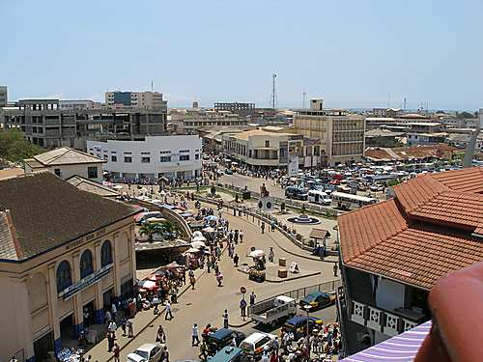
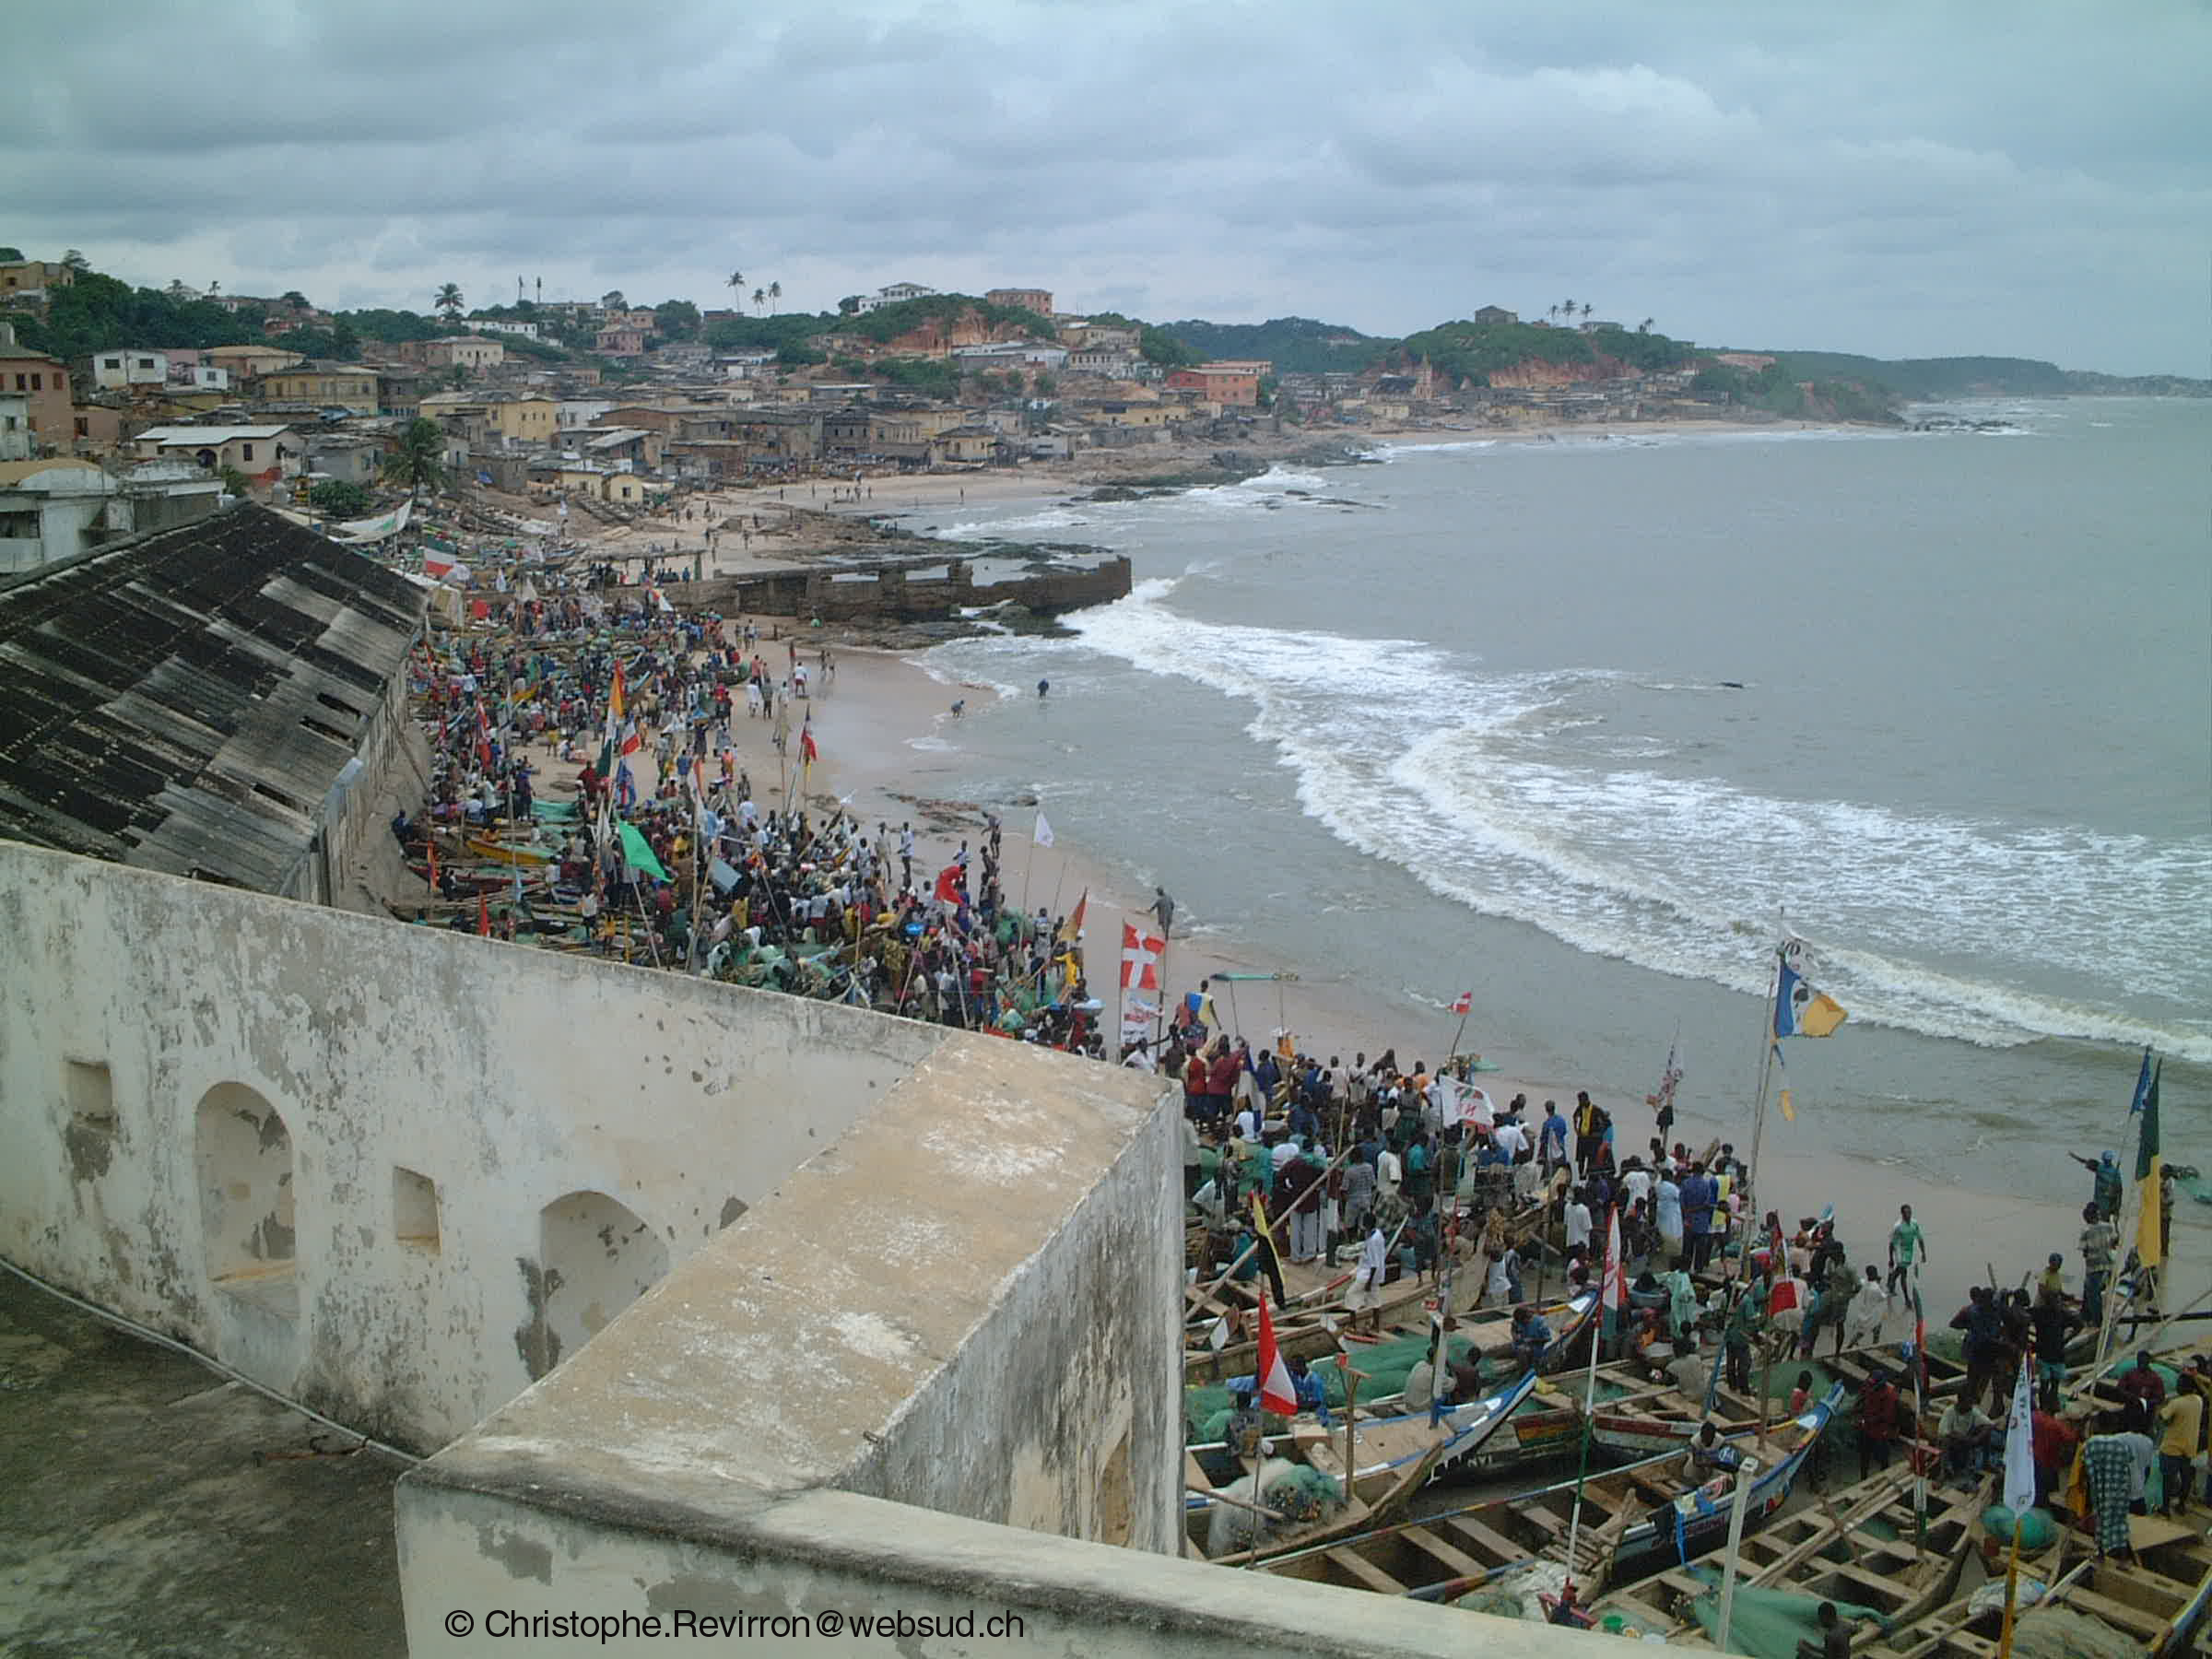
Code-X International
+31 (0)20 894 3737
+31 (0)6 2753 5843
Oudezijds Voorburgwal 314
1012GL Amsterdam, Netherlands
Email: elaine@code-x.nl
Code-X International

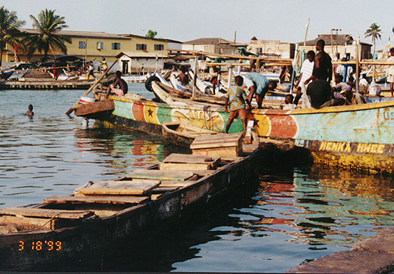
APRIL 24TH - OCTOBER 24TH 2012

Project Guidelines

Please take note of the following conditions that apply to each possible participant:
* Candidates should have a keen interest in youth and/or project development and should work well in groups and multicultural environments.

* Volunteers should be prepared to tackle the challenges associated with volunteer-work abroad including health and safety risks. Volunteers can reduce these risks by following recommendations for locally appropriate behavior, exercising sound judgment, and abiding by Code-X International policies and procedures.

*Volunteers have all of the rights and responsibilities within the EVS Charter including our effort to ensure a productive, healthy, and safe experience for volunteers through collaboration on project development with local communities, and access to a project mentor who is there to ensure support and meet with volunteers weekly.

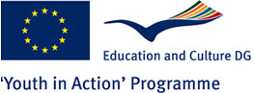

Involving Understanding Together
IT is a fast growing industry in Ghana, Africa of which more and more companies and individuals are becoming a part. This is due to a surprisingly well-coordinated connection to the Internet in the city of Accra. There are currently so many possibilities; only the poor have, thus far, no access to it. It was decided that Rhiza would start a primary/ high school in the two small towns of Suprudo and Mfuom located nearby.

A group of four to six volunteers from the Netherlands will travel to these two towns and help develop an education curriculum for primary and high school students revolving around IT. The school will need help with duties such as assisting in creating educational material, one-to-one student mentoring as well as tutoring, and helping to renovate the school.

Moreover, volunteers can also help to establish a company for the student’s families where they can work to gain experience in different services within the IT branch, such as: secretarial, technical, and security. There is also a small Internet café where they will need direction on working there and ensuring that clients are getting the information they need in addition to making sure that the computers are in working order.

Furthermore, volunteers will be able to partake in learning the local language. Weekends will be left open to undertake a variety of activities such as travel and exploring the regional landscape. Volunteers will also have the distinct possibility of creating and implementing their own projects for the foundation or within the local community.

This program involves similar projects within the EU theme of Care. This theme can be explained via different objectives, e.g. understanding the problems children face at an early age, examining how simple gestures can change the daily lives of children, and developing a cultural understanding of differences and similarities among volunteers all the while promoting worldliness.
Volunteers will become part of a group who devote their lives to the care of young children and young adults. Joining the workers means functioning as a team, recognition and acceptance as a member of the hosting organization, bonding and assisting the children and ultimately becoming part of the local community.

Interested?!?
Contact Elaine Sierra at elaine@code-x.nl

