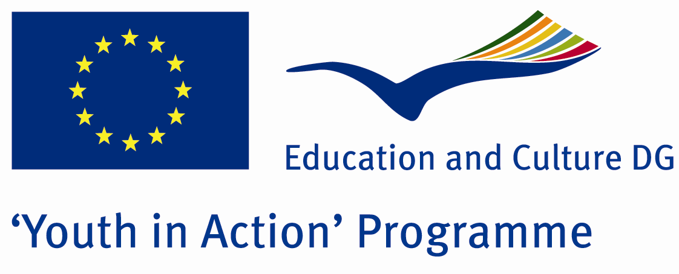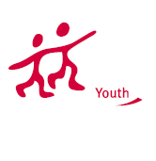

Emergency


ACTION 4.3 – Training And Networking

13-19th November , 2011

Yalova , TURKEY

Please contact directly to;
adventurerpeacepigeons@gmail.com

Project Summary;

Our project subject is radiation.All we know that radiation is everywhere.Lots of things are spreading radiation.The computers,televisions,cell phones,fridge...So we decided a project about this.Because radiation is one of reality in our life.We are living with radiation.We should do something to reduce radiation effects.In this project the participant will learn lots of thing about the radiation and they will be more conscious.After the project they will share their experiences with their neighboorhood.Let join with us...If you want to join us, please contact with us…

Project Title; Emergency

Date and Venue ; 13-19th November , 2011 Yalova, Turkey.

Target Group ; Municipalities, City Councils and Non-Governmental organizations,
youth groups,culture and art groups,e.t.c

Participants ; 5 people from each country (over 18 -25 ). Totally 8 countries.

Conditions ; Accommodation, board and programme costs will be financed through European Commission Youth in Action Programme . Travel costs will be reimbursed in 70% (APEX Tarrifs). Organizations from all 27 EU member countries plus Liechtenstein , Norway and Iceland are eligible to take part.

Working language: English

Organizer; Adventurer Peace Pigeons

How to apply: If you are interested, please send your Part III forms to
by e-mail please (in word file). Scan Part3 format is enough for application. (Fulfilled Part III which you can find in the attachment, of course signed and stamped) ..

Next step 2;
Original send via regular post to this address please:

Ertan DERİN
Fevzi Çakmak Mahallesi Tuncer Sokak No:6 PENDİK/İSTANBUL/TÜRKİYE
e-mail : adventurerpeacepigeons@gmail.com
Mobile : 0090 542 393 93 90

If you have any questions you may contact with: adventurerpeacepigeons@gmail.com

Deadline for application; until 15th May 2011.

For Further information:
Contact Person
Ertan DERİN
Fevzi Çakmak Mahallesi Tuncer Sokak No:6 PENDİK/İSTANBUL/TÜRKİYE
e-mail : adventurerpeacepigeons@gmail.com
Mobile : 0090 542 393 93 90

