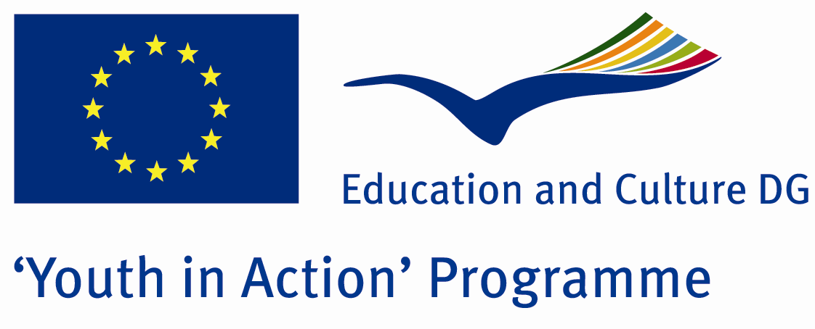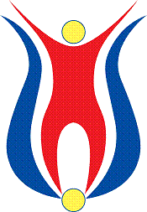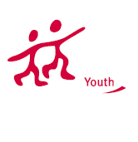

Action 1.1
Project Summary;
Have you ever thought that how many women are president or scientist in the world…Or even in the most democratic countries, how many women are there in parliament? Why do we try to behave a girl anda boy differently …What do we feel when we see a boy who is nurse or teacher of kindergarten or babysitter….What do we feel when we see a girl who is truck driver, repairwomen, or footballer…?? How many women have been died because of violence..?

In this Project, we try to take attention….Where do we live this? Especially , what kind of problems do women have?How do they prevent this?

Firstly, we give a short seminar about this subject and after that we try to learn everybody’s experiences with some art workshops…The workshops will be some kind of art like music, dance, theatre,hand art or the other…W e decide this later…These are only our some opinions..They can be changable..For this, of course we need some partners and participants..If you think to take place in this Project, please contact with us.

Project Title; Equality
Date and Venue ; 04-11 February 2012 Turkey
Place: Eskişehir

Target Group ; Municipalities, City Councils and Non-Governmental organizations,
youth groups,culture and art groups,e.t.c

Participants ; 5 people from each country (over 18 -25 ). Totally 8 countries.

Conditions ; Accommodation, board and programme costs will be financed through European Commission Youth in Action Programme . Travel costs will be reimbursed in 70% (APEX Tarrifs). Organizations from all 27 EU member countries plus Liechtenstein , Norway and Iceland are eligible to take part.

Working language: English

Organisator group: Group Eses

How to apply: If you are interested, please send your Part III forms to
by e-mail please (in word file). Scan Part3 format is enough for application.(Fulfilled Part III which you can find in the attachment, of course signed and stamped) ..

Contact e-mail: groupeses@gmail.com

