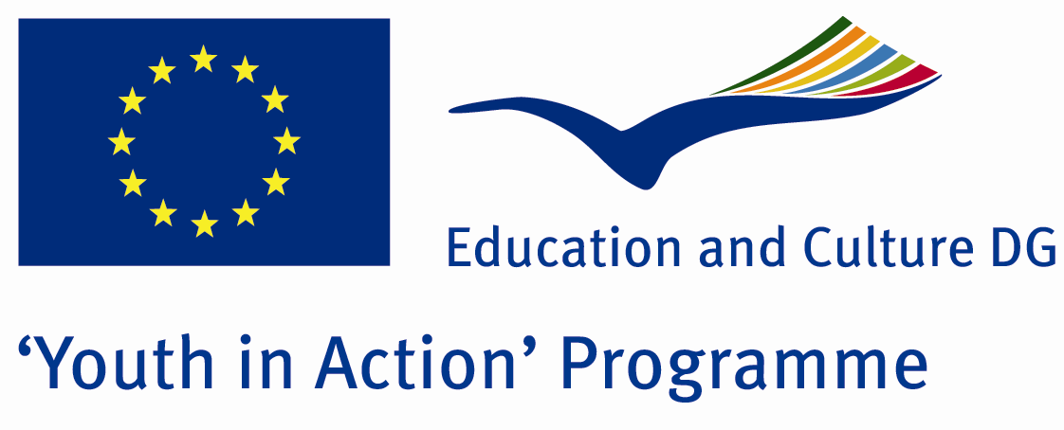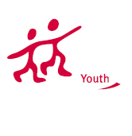

Homophobia



ACTION 1.1 – Youth Exchange

18-25th August 2011

İzmir/TURKEY

Please contact directly to;

adventurerpeacepigeons@gmail.com

Project Summary;
In this Project, we aim to take interest of the people to the homophobic manners and propaganda against gays&lesbians. Today, in every 48 hours a gay is being killed because of homophobia. According to amnesty international, in 70 countries the gays&lesbians are suffering from homophobia and in 8 countries gays&lesbians are executed because of their sexual choices. Even in the many European countries and Turkey as well. That’s why we need this project to understand and try to find solutions against this problem. With this project, we will also contribute to the peace in the society and hopefully decrease the discrimination against gays&lesbians. I hope you will join us….please for cntact use information in info packs.

Project Title; Homophobia

Date and Venue; 18-25th August 2011 İzmir/TURKEY

Target Group; Non profit/non governmental organization, Public body, Body active at European level in the field of youth (ENGO), Informal group of young people, e.t.c…

Participants; 5 people from each country (18 - 25). Totally 8 countries.

Conditions; Accommodation, board and programme costs will be financed through European Commission Youth in Action Programme (Action 1.1). Travel costs will be reimbursed in 70% (APEX Tarrifs). Organizations from all 27 EU member countries plus Liechtenstein , Norway and Iceland are eligible to take part.

Working language: English

Organizer; Discovery And Adventure Group

How to apply: If you are interested, please send your Part III forms to
0090 216 483 21 67 by FAX please. (Fulfilled Part III which you can find in the attachment, of course signed and stamped) ..

Note: jpeg is not allowed..please send by fax…

Next step 2;
Original send via regular post to this address please:

Ertan DERİN
Öner İnşaat
Abdulhalik Renda Cd.
Parlar Sk. No:4 Pendik/İSTANBUL
If you have any questions you may contact with: adventurerpeacepigeons@gmail.com
Deadline for application; until 20th January 2011.

For Further information:
Contact Person
Ertan DERİN
Öner İnşaat
Abdulhalik Renda Cd.
Parlar Sk. No:4 Pendik/İSTANBUL

e-mail : adventurerpeacepigeons@gmail.com
Mobile : 0090 542 393 93 90
Fax : 0090 216 483 21 67

