Info pack

European voluntary service project “Friendship in box 2

Dates: 07.04.2016-07.01.2017

Place: Kazanlak, Bulgaria

Hosting organization summary:

“Youth development center-Mutual aid” (YDCMA organization) was founded in 2004. The main idea of organization is to support the development of young people by helping them to develop their physical, creative and spiritual qualities to be good citizens of Republic of Bulgaria
YDCMA organization organized the following EVS projects:
Project “Eco festival Koprinka 2015”-12 EVS volunteers from Slovakia, Poland, Spain and Romania.
Project „Friendship in Box”- 4 EVS volunteers from Spain, Sweden and Germany;
Project „Ecology Development III” -12 EVS volunteers from Poland, Slovakia and Italy;
Project „Ecology Development Two” -12 EVS volunteers from Poland, Hungary, Macedonia and Latvia;
Project „Ecology Development”-1 EVS volunteer from Lithuania;
Project “A new beging”-3 EVS volunteers from Slovakia, Poland and Latvia;
Project “Art to give”-2 EVS volunteers from Turkey and Lithuania;
Project “Art vision”-1 EVS volunteer from France.

Web site: http://www.ydcma.org
Contact person: Mariya Slavova, e-mail: mslavova@ydcma.org, phone: +359 899 307 090

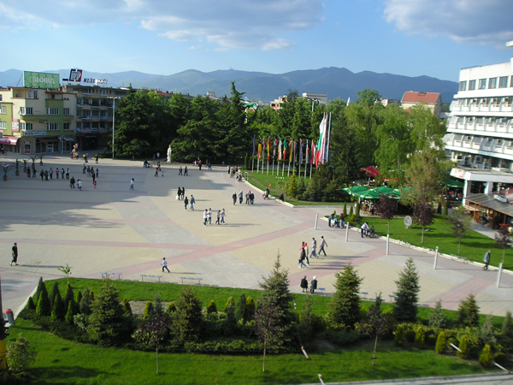
(view of Kazanlak)

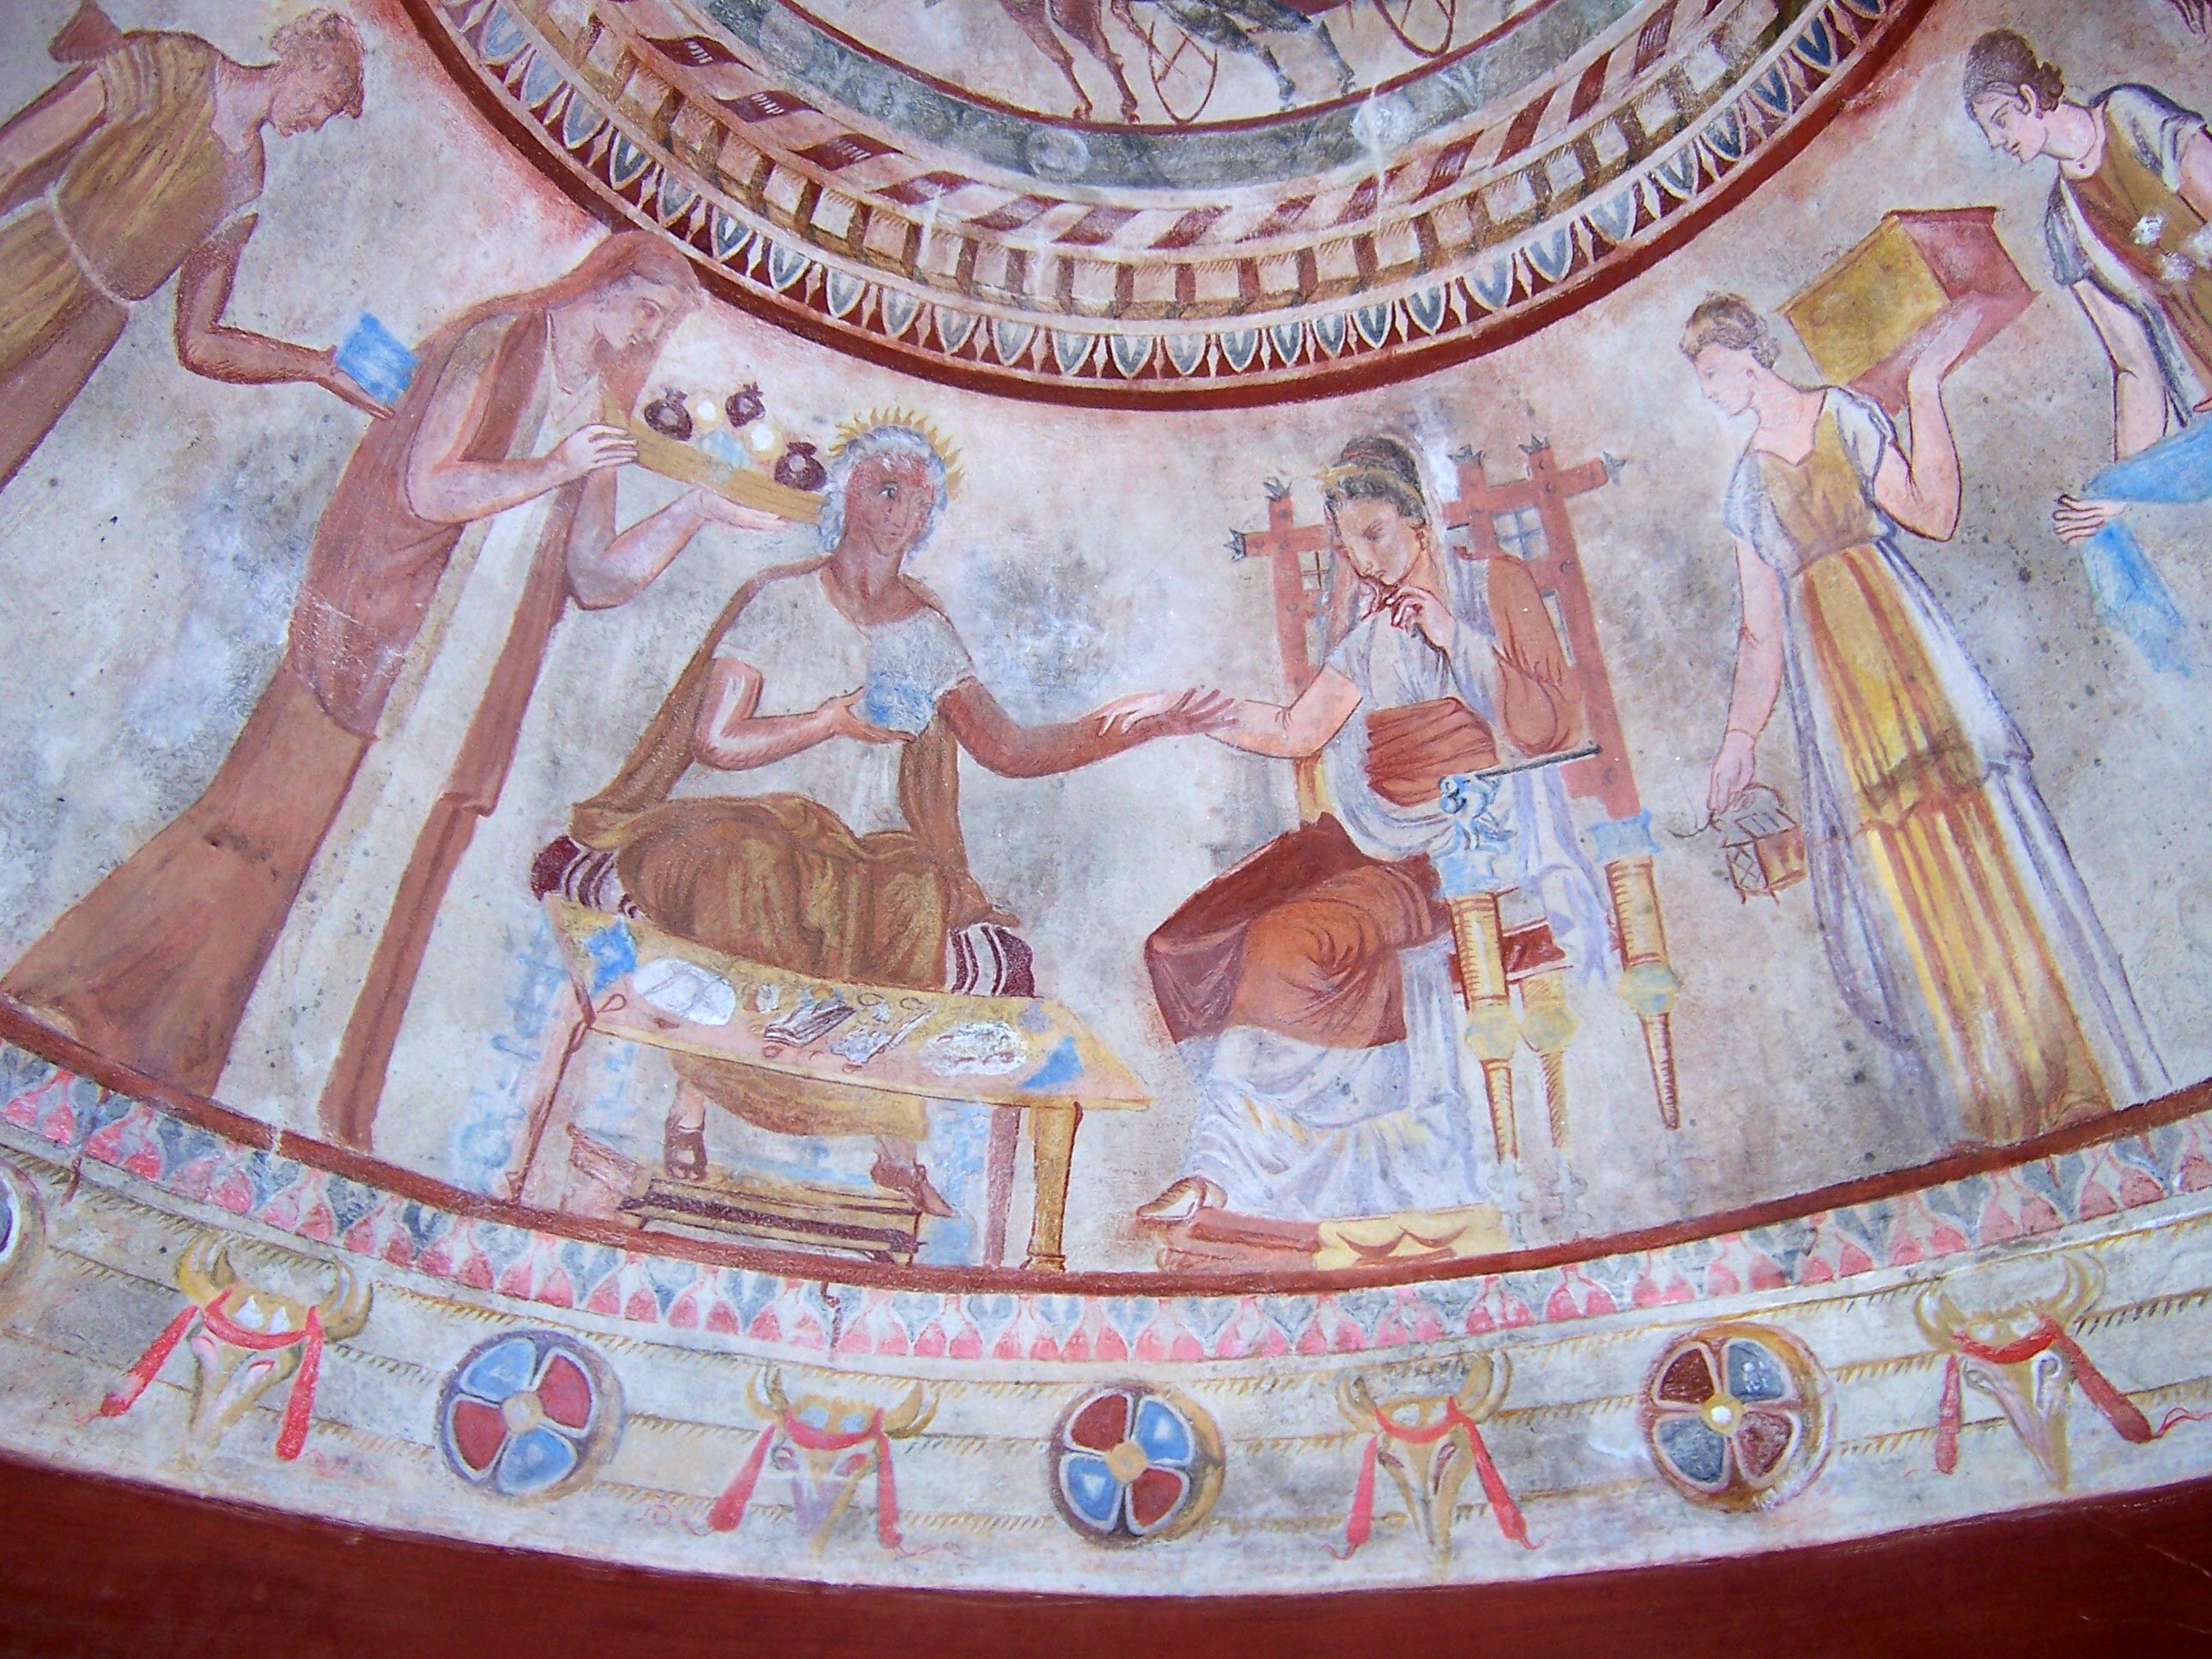

(the Thracian tomb, UNESCO world cultural heritage site)

Project summary:

During two time periods of night months each, the six volunteers will be active participants in working youth groups which will be organized in accordance with the project at the Daily care center for disabled children and youth, the Houses for elderly people Nr. 1 and 3 in Kazanlak, Bulgaria. The participating volunteers will be given the opportunity to be involved in the routine activities of our organization and our partners, focused on the formation of a sense of tolerance and empathy towards the children that are different, and change of people’s prejudices towards disabled people and elderly people, as well as improving the image of the local institutions and organizations. The project’s main goal is through volunteers’ activities and art-therapeutic sessions with the partner organizations, the children to be taught systematically to accept the different people and to create messages of friendship with the other children. The volunteers will have the chance to learn more about the disabled children and youth who are grown in a family environment, and the concomitant issues. The project will also be focused on the youth initiatives of the EU as a means for assisting citizens’ initiative and motivation, and increasing young people’s adaptivity abilities and their skills for working with disabled children and tolerance towards the elderly. Other activities will be: organizing meetings with various experts in fields, in which the volunteers are interested and assisted by the experts, and popularization of the project through publishing a newsletter “The(Y) volunteers”.
The project is countenious of another project which was organized by the receiveing organization from 2013 to 2014 year with 4 EVS volunteers from Spain, Sweden and Germany in Daily care center for disabled children and youth and Houses for elderly people Nr. 1 and 3. The good results of that motivate the team and the institutions to create a new project.

Main activities are as follow institutions:
- Daily care center for disabled children and youth;
- Houses for elderly people Nr. 1 and 3;
- Newsletter “The(Y) volunteers”.

Location of Kazanlak:

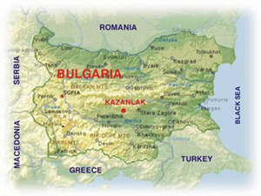

How to reach Kazanlak:

The best way to reach Kazanlak is from Sofia (there is the biggest airport in Bulgaria). From Sofia airport you have to take the metro. The ticket costs 1 lev for a passenger (please take into consideration that passengers with big baggage pay additional ticket for 1 BGN). You have to get off at Central railway station (Централна гара).

Map of Sofia metro:
http://www.metrosofia.com/images/sofia-metro-lines-may-2015.pdf

It is possible to catch a taxi. You should walk a little on the right of the exit of the terminal and you will see plenty of taxis there. The most reliable are “OK taxi”. The price to the railway station might be between 10-12 BGN.

There are two options to get to Kazanlak from there: to take a train (recommended) or bus.

By train:

- Train to Burgas (Бургас) 7:45 (arrives in Kazanlak at 11:17). Ticket costs 11.40 BGN. For groups between 3 and 6 people the ticket for 1 person costs 9.70 BGN.

2. Train to Burgas (Бургас) 13:00 (arrives in Kazanlak at 16:30). Ticket costs 11:40 BGN. For groups between 3 and 6 people the ticket for 1 person costs 9.70 BGN.

3. Train to Burgas (Бургас) 16:30 (arrives in Kazanlak at 19:40). Express train with mandatory seats reservation. Ticket costs 15.40 BGN. For groups between 3 and 6 people the ticket for 1 person costs 13.30 BGN.

4. Train to Varna (Варна) 22:30 (arrives in Kazanlak at 1:49). Ticket costs 11.40 BGN. For groups between 3 and 6 people the ticket for 1 person costs 9.70 BGN.

We don’t recommend buying tickets on-line because the on-line reservation system is still subjected to tests.

The website of Bulgarian railways:
http://www.bdz.bg/en/

By bus:

The central bus station is located about 50 m from the railway station (warning: there is another small bus station in front of the railway station). You have to search for the ticket desks where they sell tickets to Kazanlak.

10:30 (company: Kumaks/Кумакс). Ticket costs 17 BGN. The duration of the journey is about 3.30 h.

15:00 (the same company)

17:30 (the same company. Instead of a bus, you will travel by a mini bus, so we don’t recommend this hour of departure))

The name of Kazanlak in Bulgarian is written Казанлък. The second “a” is pronounced like “I” in “first”.

Accommodation:

Organisation will provide a fully equipped private house. Participant will share it with other participants in the activity. Participant will prepare his/her meals on his/her own or together with roommates. Participant is responsible for cleaning his/her clothes and house. Participant is responsible for keeping the living area clean and to take care of the equipment. Participant should keep silence between 23:00 p.m. to 07:00 a.m

Pocket money and money for food:

Pocket money in amount of 70 euro per month. The instalment will be paid within the first 7 days of the month.
Money for food in amount of 100 euro per month. The budget of money for food will be given in the middle of the month. Volunteers will have to cook together and buy products for food together, thereby being able to prepare more food for themselves.

Travel expenses:

According to the conditions of the Erasmus + programme, participants in EVS project can have their travel expenses reimbursed within the amount given below. The reimbursement covers your departure from your home town (residence) to the place of activities (Kazanlak). You must depart from the country you represent: for example, if you are a representative of Germany, you must depart from Germany.

The reimbursement covers only traveling by plane, train and bus. Money paid for taxi cannot be reimbursed! Please keep all receipts and invoices with you.

Country | Travel expenses covered by the project
France | 230
Germany | 275
Spain | 230

Other practical advices:

Insurance: We advice every participant to get a European Health Insurance Card, and to ask the sending organization for more info about the insurance company that Erasmus + programme covered.

Weather: The weather in the beginning of april could be warm. In the past years the temperatures reached 15-20 degrees.

Currency: The currency in Bulgaria is lev (BGN). Its rate to Euro is fixed on 1 Euro = 1.955 BGN.

Language: Bulgarian is a Slavic language. Young people often speak English, but people like drivers, ticket sellers, shop assistants usually do not speak English, so it is good if you learn some useful phrases in Bulgarian (see below).
The alphabet used in Bulgaria is Cyrillic, so it is recommended also to get some knowledge about it.

Useful phrases in Bulgarian:

Да (da) - yes

Не (ne)- no

Добър ден (dobyr den) – Hello (official)

Добро утро (dobro utro)- Good morning

Лека нощ (leka nosht)- Good night

Здравей/здравейте (zdravey/zdraveyte) – Hello (to 1 person/to more persons)

Довиждане (dovijdane)- Goodbye

Чао (chao)- Bye (informal)

Аз съм от (Az sym ot)- I am from:

-Испания (Ispaniya) Spain
-Полша (Polsha) Poland
-Словения (Sloveniya) Slovenia
-Португалия (Portugaliya) Portugal
-Унгария (Ungariya) Hungary

Извинете (izvinete)- excuse me

Благодаря (blagodarya)- thank you

Моля (molya)- please, you are welcome

Не разбирам (ne razbiram)- I don’t understand

Говоря английски- I speak English

Извинете, къде е автогарата/гарата/тоалетната? (izvinete, kyde e avtogarata/garata/toaletnata)- excuse me, where is the bus station/rail station/toilet?

Влак (vlak)- train
Гара (gara)- railway station

Автобус (avtobus)- bus
Автогара (avtogara)- bus station

Един билет/два билета/три билета/четири билета/пет билета до Казанлък (edin bilet/dva bileta/tri bileta/chetiri bileta/pet bileta do Kazanlak)- One/two/three/four/five tickets to Kazanlak

Колко струва това? (Kolko struva tova)- How much is this?

Търся... (tyrsya)- I am looking for…

Additional phrases: http://wikitravel.org/en/Bulgarian_phrasebook

