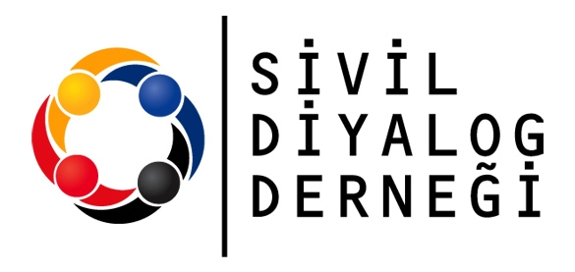 | 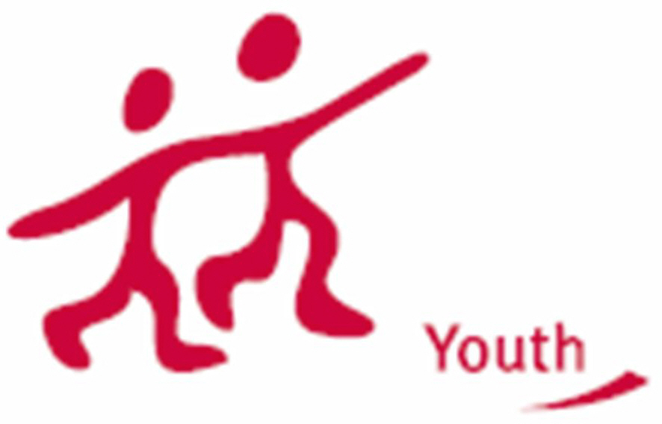

LET’S DO DEMOCRACY

Training course on Action 1.3 of the YiA Programme
8 – 13 February 2011

Are/do you ?

- working with young people?
- actively involved/ are you willing to be actively involved into democratic and decision making processes existing in your local community?
- want to create an Action 1.3 Youth Democracy project in cooperation with other European groups of young people?
- want to acquire project management and communication competencies for the local and international activities developed within your Youth Democracy project?
- interested in developing understanding about the principles of youth ,participation?
- Do you want to explore the added value of Youth Democracy Projects for the local community?

Then the Training Courses on Action 1.3 Youth Democracy Projects might be for you!

Objectives of the TC

LET’S DO DEMOCRACY Project supports this vision through a common curriculum which fulfills six objectives, namely to:

- To explore the added value of Youth Democracy projects for the local community
- To acquire project management and communication competencies
- To develop understanding about the principles of youth participation
- To learn about the Youth in Action Programme and especially about the quality criteria of Action 1.3 Youth Democracy project
- To create a space for contact making and finding potential partners for Youth Democracy projects
- To develop an action plan to realise a Youth Democracy project

Target Group

We are looking for people who are young people, youth leaders, youth workers, representatives of associations, student councils, youth councils and public officers:

- Willing to apply for an Action 1.3 Youth Democracy project after the course
- Representing an organisation or a local authority or a group of young people
- Able to talk and work in English
- Live in any of the YOUTH IN ACTION programme countries: 27 EU countries + Iceland, Liechtenstein, Norway, Turkey.

What is All About

The programme is designed to give you knowledge and skills to develop and realise your Youth Democracy project after the course. The following elements can be in the program:
- YOUTH IN ACTION programme. You will get information about the YOUTH IN ACTION programme and particularly the criteria of Action 1.3 Youth Democracy projects
- Concept of participation. You will reflect on the concept of youth participation to get a better understanding.
- Project management. You will reflect on current needs in your local community. You will define concrete project ideas to answer those needs. You will set up the first steps development of your Youth Democracy project.
- Teamwork and the partnerships. You will be given suggestions to help work in teams (at local and international level): decision-making process, division of tasks, and cooperation between the partner groups.
- Intercultural setting. You will meet people from all over Europe to exchange experiences, work on participation, develop future actions etc
- Contact making. You will get to know each other projects and organisations and will have the opportunity to further develop cooperation with them.

Say hi
Introductions (course program, YiA general, Action 1.3)

development of
YD project ideas

Conceptual framework of youth participation

Youth participation in “real life”

Why YD projects ?

Project management in “real life”

European Citizenship and Non-Formal Education

Conceptual framework of project management

Feedback and action
planning

Methodology

The Training Course will be based on the principles and practice of non-formal education taking into account your needs, motivations and previous experiences as starting point of the programme. A diversity of working methods will be used for learning about Youth Democracy project management: thinking together, brainstorming, creating new ideas, discussions, debates, simulations, etc. You will be supported actively to work on concrete projects and enabled to apply for Action 1.3 of the YOUTH IN ACTION programme.

Where and When?

The training course will be organised in Bursa Turkey from the 8 to 13 February 2011

Venue: Bursa Turkey
Bursa is a city in northwestern Turkey and the seat of Bursa Province. With a population of 2,550,645 (2009),[ it is Turkey's fourth largest city, as well as one of the most industrialized and culturally charged metropolitan centers in the country.
Bursa is settled on the northwestern slopes of Mount Uludağ in the southern Marmara Region. It is bordered by the Sea of Marmara and Yalova to the north; Kocaeli and Sakarya to the northeast; Bilecik to the east; and Kütahya and Balıkesir to the south.
The city is frequently cited as "Yeşil Bursa" (meaning "Green Bursa") in a reference to the parks and gardens located across its urban tissue, as well as to the vast forests in rich variety that extend in its surrounding region. The city is synonymous with Mount Uludağ which towers behind its core and which is also a famous ski resort.
Bursa is also home to some of the most famous Turkish dishes, especially candied chestnuts and İskender kebap. Its peaches are also well-renowned.

Organisers: Civil Dialogue Association

Civil Dialogue Association has been established to foster the dialogue among different parts of the society, support the development of Civil Society and increase the awereness of Turkish Citizens about the EU Accession. We run several projects both in local, national and international level in order to let the society enliven and take their part into the decision-making process. Our ambition is to create an active, responsible, galvanized and creative community. In order to reach the objectives of our Association, we have applied for a project to Turkish National Agency right after the establishment; and our project, EU Youth Program Action 5.1, namely “Structural Dialogue for Youth”, has been implemented in 2010. The project gave youngsters opportunities to compose local youth policies. Moreover the Association deals with other youth projects, specifically European voluntary Service.

Civil Dialogue is also an accredited organization in European Voluntary Service ( Action 2) by sending and coordinating activity. So far we have more then 10 volunteers abroad and host 8 volunteers in Turkey.

For more info: www.sivildiyalog.org

Funding Conditions

70% of travel costs, 100% of food and lodging costs and exceptional costs such as actual costs covering visa, visa-related costs and vaccination costs, as well as costs related to participants with fewer opportunities/ special needs will be covered.

*Partnes or particiapnts are just obliged to cover their participants’ 30% of travel cost

Working Language

English

Interested ?

Please send your (part III) Partnership Agreement (in English) to us by fax firstly
(0090 224 222 1300) and then send it by post

Deadline for Applicants 26 August 2010

Contact Persons

Contact Person: Mrs. Gulsun Bayraktar- Project Development Officer
info@sivildiyalog.org
Address: Haşim İşcan Cd. Tugtas 1 İs Mrk No:12 Ofis 203
Osmangazi Bursa 16100
TÜRKİYE (TURKEY)

Tel: 00 90 224 2223939
Fax: 00 90 224 2221300

Outline
http://sivildiyalog.org/lets_do_democracy.doc

Part III
http://sivildiyalog.org/PartIII.doc
LET’S DO DEMOCRACY
BURSA, TURKEY 8 – 13 February 2011
 | Monday | Tuesday | Wednesday | Thursday | Friday | Saturday | Sunday | Monday
09:15 | Arrival | Energizer | Energizer | Energizer | Energizer | Energizer | Energizer | Good bye
9:30 - 11:00 | Arrival | Opening Ceremony Get to know each other | YiA | Youth Democracy | European Citizenships | Non-formal Education | Presentation of prepared projects | Good bye
9:30 - 11:00 | Arrival | Who is, who? Where do we come from? Ice breakers + name game
11:00 - 11:30 | Arrival | Coffee Break | Coffee Break | Coffee Break | Coffee Break | Coffee Break | Coffee Break | Good bye
11:30 -13:00 | Arrival | Presentation of the TC Aims & objectives | Youth Participation | Life Learning Exercise | Quality in Projects | Local Participation for Youth | Presentation of prepared projects
11:30 -13:00 | Arrival | Expectations and Worries
13:00 - 15:00 | Arrival | Lunch | Lunch | Lunch |  | Lunch | Lunch
15:00 - 16:30 | Arrival | DISCOVERING THE CITY | Organization Fair | PCM (Project Cycle Management) | Project Ideas | Project Development | Action Plan
16:30 - 17:00 | Welcome Section | DISCOVERING THE CITY | Coffee Break | Coffee Break | Coffee Break | Coffee Break | Coffee Break
17:00 - 18:30 | Welcome Section | DISCOVERING THE CITY | Organization Fair | PCM in Action ! | Project Ideas | Support and development | General Evaluation
18:30 - 19:00 | Welcome Section | DISCOVERING THE CITY | Daily evaluation | Daily evaluation | Daily evaluation | Daily evaluation | General Evaluation
19:00 - 20:30 | Dinner | Dinner (outside) | Dinner | Dinner | Dinner | Dinner | Dinner (outside)
20:30 | Say hi | Dervish Show | Social Activities | Free Night | International Evening | Preparing for tomorrow | Firewall Party

