Partner Request for the project
Updated 20.01.2010

Vote for (YOU)th!

1.3 Youth Democracy Project

Voting is the main part of democracy. A voting system allows voters to choose among options, often in an election where candidates are selected for public office. Every country has different voting systems derived from its history, culture and political system.

Most of the population lives in cities. Therefore local governments are always getting more attention then ever before. Local government is the tier of public authority that citizens first look at to solve their immediate social problems. It is also the level of democracy in which the citizen has the most effective opportunity to actively and directly participate in decisions made for all of society.
The question of youth electoral participation is becoming increasingly important around all Europe. Academic studies indicated that young people vote at rates that are significantly lower than those of older generation. In addition, today's youth are not showing signs of becoming more likely to vote as they age. Moreover, each successive generation appears to be less inclined to vote than its predecessors. Together, these trends suggest the recent declines in overall voter turnout will continue into the future.
The reasons for declining turnout among young people are many. Low levels of political interest and knowledge, a declining sense that voting is a civic duty, certain administrative difficulties, and limited contact with political parties and candidates are the most frequently identified factors.
!You can find a draft program of the project
on the next pages of this call!

Idea
The idea of the project comes from the lack of youth participation in elections and different policies for young people to increase their voting participation. The project will take part in Turkey and 3 other partner countries in 2010. The project is focusing on training 24 youth from those 4 countries to take an active role in the political life of the country and to increase ability of youth to evaluate different political parties and their different policies for local area. Also during the activities of the project, young people will have a chance to understand different elections systems, learn how young people vote for and how political youth organizations attract to young people.

Objectives of the Project

- Increasing the awareness of the importance of youth participation in democratic processes;
- Supporting young people to take an active role in the political life of the cities;
- Fostering young people to get better consciousness for their decisions in voting;
- Understanding the different electoral systems around Europe;
- Raising awareness about what democratic and transparent elections are.

Practical Information
Dates

The project will take place from June 2010 to March 2011. It will last 10 months.

Turkey Visit (Coordination Visit) August 2010 3 Days
Partner Country 1 Visit September 2010 2 days
Partner Country 2 Visit December 2010 2 days
Partner Country 3 Visit January 2011 2 days

Participants

We anticipate young participants from our partners who are eligible to vote in their countries and are still within the age-limit of Youth in Action Programme (15-30 years old).

The project involves 4 countries and 2 partners from each country (organizations from the same country should be from the same city), totally 8 organizations. From each country, 6 young people will take part in all activities of the project in 4 countries, totally 24 young people.

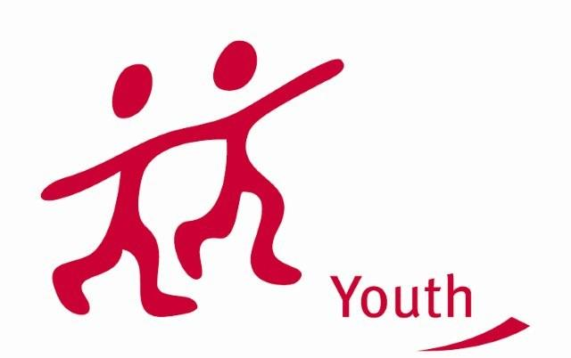
Financial conditions

Travel costs, accommodation/food costs, organization of seminars, meetings, consultations, activities, publications/translations/information costs, dissemination and exploitation of results. Other costs directly linked to the implementation of the project are covered by 75 % from the EU Grand.

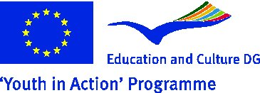
Due to coo-financing, the project covers %70 of travel cost of each participants and %100 /food costs, Organization of seminars, meetings, consultations, activities, - publications/ translations /information costs, Dissemination and exploitation of results, Other costs directly linked to the implementation of the project

Deadline
We strive to meet the 1 February 2010 deadline for the project to be sent to the Turkish National Agency and would be very happy if we could include your comments and suggestions.

Therefore we would be very pleased to receive your expression of interest and your signed Part III form before January the 25th, both digitally and via regular mail or fax.

Description of the OrganisationS

Osmangazi Municipality EU Coordination Center

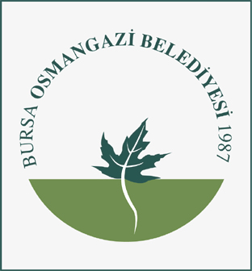
The goal of Osmangazi Municipality in view of this project is mainly to foster youth participation in public life and by extension in the democratic process of elections. In general the main objective of the EU Coordination Center is to raise awareness among youngsters about European Union youth projects and policies. Considering democracy not only as a procedure but as an ongoing process that needs to be fed, our most general aim is fostering a larger participation in local life (not only in politics). As a key part of society, youth is a privileged target of all our activities.

Activities

Osmangazi Municipality is a local authority and a metropolitan district of the Bursa Province in Turkey. Our social activities concern many fields such as education, youth activities, sport activities, social services (centre for social rehabilitation and integration of blind people, social services complex, daily care centre for mentally disabled persons) , cultural activities, youth services (youth office and council), women office and council.

Osmangazi Municipality pays also a great attention to European projects and programmes, particularly concerning youth (also European Voluntary Service). Osmangazi Municipality has carried out many projects in this field as the “Youth democracy projects for culture”, a project that deserved to be financed by the Turkish National Agency among many others. All the activities aim at social inclusion and citizen participation with a special attention to all categories with fewer possibilities.

Currently Osmangazi Municipality is taking the lead in a national youth networking project (Action 5.1) about Local Youth Policy: “Structured dialogue on Local Youth Policy”. In a partnership with seven of the biggest municipalities of Turkey, youngsters from all over the country are discussing topical issues and putting forward creative proposals concerning Local Youth Policy in Turkey. With the project “Local Youth Policy – Municipality’s Priority” we want to bring our experience in this field to a higher level, developing a transnational network.

Youth Governance Association
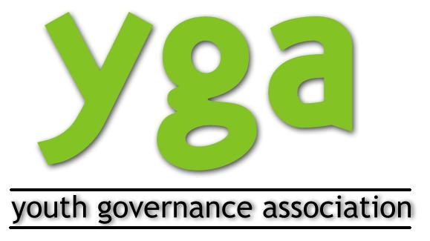
Youth Governance Association (YGA) is a newly found organization by youngesters and youth leaders in February 2008. The organization is based in Bursa Turkey. Though the association was recently found, the founders are experienced youth workers who took part in many projects as either organizers or trainers.

Having opportunity to get in touch with other cultures and organizations, young people of local community are getting interested in taking part in long-term projects in order to have the experience of living in a different environment. Not only sending young people to another country, but also hosting volunteers in our organization is in great importance for us. Diversity of volunteers working in the organization will bring a fresh breath to our way of thinking.

YGA was caring out also a European Youth Project 5.1 titled “Innovative Approaches for Youth Participation” in 2009 was reward one the best project in Turkey during 2009 by Turkish National Agency. You can get more info on www.youth-participation.org

Contact Detaıls

Contact Person: Mr. Ali GÜLBAY – Coordinator

Address: Osmangazi Belediyesi Avrupa Birliği Koordinasyon Merkezi
Santral Garaj Mah. Ulubatli Hasan Blv. No: 6
Osmangazi Bursa 16100
TÜRKİYE (TURKEY)

Tel: 00 90 224 2707056
Fax: 00 90 224 2707019

E-mail: aligulbay@osmangazi.bel.tr

Web: EU Coordination Center: www.osmangaziab.org
Osmangazi Municipality: www.osmangazi.bel.tr
Youth Governance Association www.youthgovernance.org

Activities of the Project
Draft Program

Turkey Visit (Coordination Visit) August 2010 3 Days
Day 1

- Opening Ceremony - Get to know each other
- Who is, who? Where do we come from? Ice breakers + name game
- Coffee Break
- Presentation of the Project’s Aims & objectives
- Expectations and Worries
- Lunch
- Workshop: Youth participation
- Coffee Break
- How do we vote? – different electoral systems and ways of voting (comparison among countries)
- Dinner
- Cultural Activities
Day 2

- Energizer
- Visit to political youth parties/organizations in Local Level: How they involve young people? How they undestand young people? How they develop strategy for young people?
- City tour
- Lunch
- Interviews to young people about elections: how they decide to vote?, what are the criterias for young people to vote?, General understanding of youth voting
- Coffee Break
- Dinner
- Free Night
Day 3

- Energizer
- Analysis and outcomes of Interviews
- Coffee Break
- Role Game: my election
- Lunch
- Coordination of project activities
- Coffee Break
- Evaluation of the visit
- Dinner
- Bye Bye Party

Partner Country 1 Visit September 2010 2 days
Day 1

- Hello Again
- Group Building Activities
- Coffee Break
- Detailed overview about youth participation in the elections in Partner Country 1: the percentagee of youth participation, role of youth organization, the electrol system,...
- Lunch
- Visit to youth political parties/organizations in Local Level : How they involve young people? How they undestand young people? How they develop strategy for young people?
- Dinner
- Cultural Activity

Day 2

- Energizer
- Interviews to young people about elections: how they decide to vote?, what are the criterias for young people to vote?, General understanding of youth voting
- Lunch
- Analysis and outcomes of Interviews
- Coffe Break
- Evaluation of the Visit and Follow Up
- Dinner
- Bye Bye Party

Partner Country 2 Visit NOVEMBER 2010 2 days
Day 1

- Hello Again
- Group Building Activities
- Coffee Break
- Detailed overview about youth participation in the elections in Partner Country 2: the percentagee of youth participation, role of youth organization, the electrol system,...
- Lunch
- Visit to youth political parties/organizations in Local Level : How they involve young people? How they undestand young people? How they develop strategy for young people?
- Dinner
- Cultural Activity

Day 2

- Energizer
- Interviews to young people about elections: how they decide to vote?, what are the criterias for young people to vote?, General understanding of youth voting
- Lunch
- Analysis and outcomes of Interviews
- Coffe Break
- Evaluation of the Project
- Follow Up
- Dinner
- Bye Bye Party

Partner Country 3 Visit January 2011 2 days
Day 1

- Hello Again
- Group Building Activities
- Coffee Break
- Detailed overview about youth participation in the elections in Partner Country 2: the percentagee of youth participation, role of youth organization, the electrol system,...
- Lunch
- Visit to youth political parties/organizations in Local Level : How they involve young people? How they undestand young people? How they develop strategy for young people?
- Dinner
- Cultural Activity

Day 2

- Energizer
- Interviews to young people about elections: how they decide to vote?, what are the criterias for young people to vote?, General understanding of youth voting
- Lunch
- Analysis and outcomes of Interviews
- Coffe Break
- General Evaluation of the Project
- Follow Up
- Dinner
- Bye Bye Party

