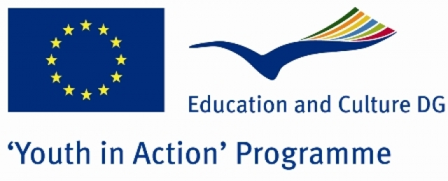

PROJECT DETAILS

„Kolbastı” Uniting World Youth

Action 1.1. Youth in Action Programme
Ankara (Capital City)
Turkey
5-14 September 2010

General Context of the project:

We invite young people from all status to join around ‘kolbastı’, a traditional Turkish folk dance which has a uniting, peace-giving, integrating, animating, and energy-yielding power and aim to remove all the obstacles, such as ethnicity, gender, age or different backgrounds, in front of communication. The project also aims at teaching traditional Kolbastı dance to young people from different social status in order to provide a communication by reducing differences and supporting similarities between them. The project takes 10 days including the travel. Kolbastı dance figures will be taught to te participants by Turkish trainers and our traditional dance team for five days. In the reamaining days, all the figures learnt so far will be performed by all the participants. This performance will also take place in Shopping Centres, local TV channels, fairs, and at a special night organisation, held by the participants. As a result of the project, they will intoduce and present Kolbastı dance and will prepare a website which inroduces and teaches this dance.

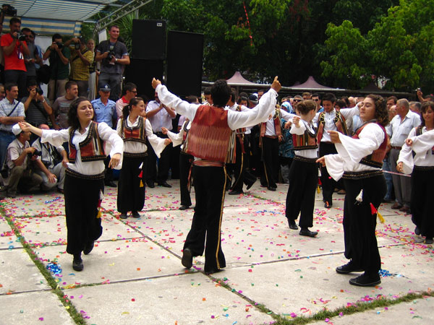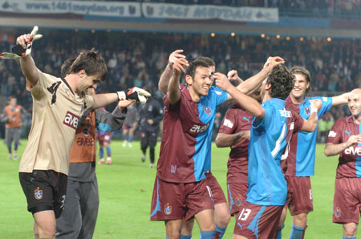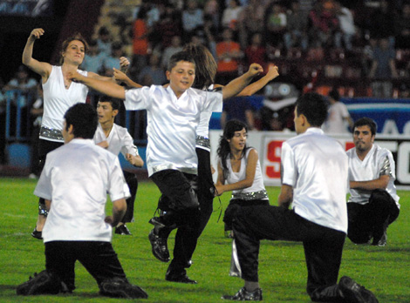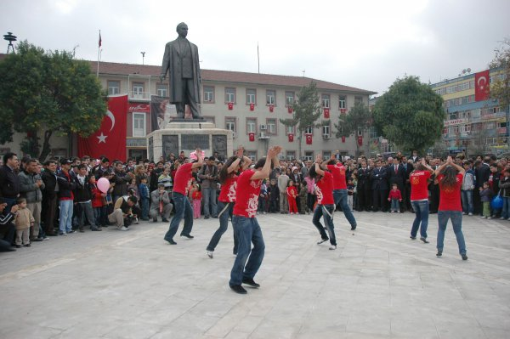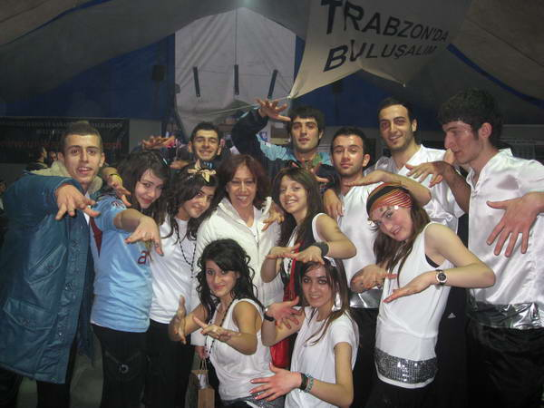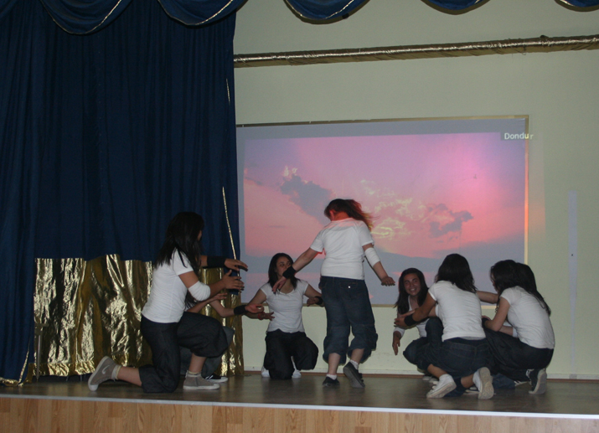

About Us:

Our group, between 15 and 19, are girls from different socio-economical and cultural status.
It is an informal group consisted in a high school. The group members are mainly educated in the field of public relations and organisation. They have had a dance education. They performed Kolbastı in several places. Its facilites and training are still going on inside or outside the school.

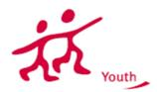

___________________________________________________________

Activities:

- The definition of Kolbastı
- Teaching the figures of the dance
- The performance on the stage
- The organisation of a Culture Night.

Target Group:

Participants must be between 13-20. Group leaders can be older.

Funding:
70% of travel costs, 100% of food and lodging costs and exceptional costs such as actual costs covering visa, visa-related costs and vaccination costs, as well as costs related to participants with fewer opportunities/special needs will be covered.

Partners:

All Youth in Action Program countries.
As the project will be applied to the Youth in Action Programme, we kindly ask you to send us your singed and stamped Part III via email to youthmedeni@gmail.com

Contact:
Medeni Coşkun (Project Manager)
E-mail: youthmedeni@gmail.com
Phone: +905053598933
Deadline Date: 23.03.2010
After evaluating all the application forms, we will contact with accepted partners on the 24th of March.

Program of the project:

„Kolbastı” Uniting World Youth
5-14 SEPTEMBER 2010
ANKARA
TURKEY

PROJECT SCHEDULE
DAYS | MORNING |  | AFTERNOON |  | EVENING
 | 09:30 – 10:30 | 11:00 – 12:00 | 13:30 – 14:30 | 15:00 – 16:00 | 18:00-22:00
05 .09. 2010 Sunday | Arrival of the participants & Tour in another city |  |  |  | Check-in for the hotel
06.09.2010 Monday | Welcome Speeches and the meeting of participant country members.  The presentation of “Kolbastı”. |  |  |  | 1st cultural night
7-10 September 2010 | Teaching the figures of the dance |  |  |  | Free time
11-13 September 2010 | The performance on the stage |  |  |  | 2nd cultural night
14.09.2010 | Finalishing the report for the website

