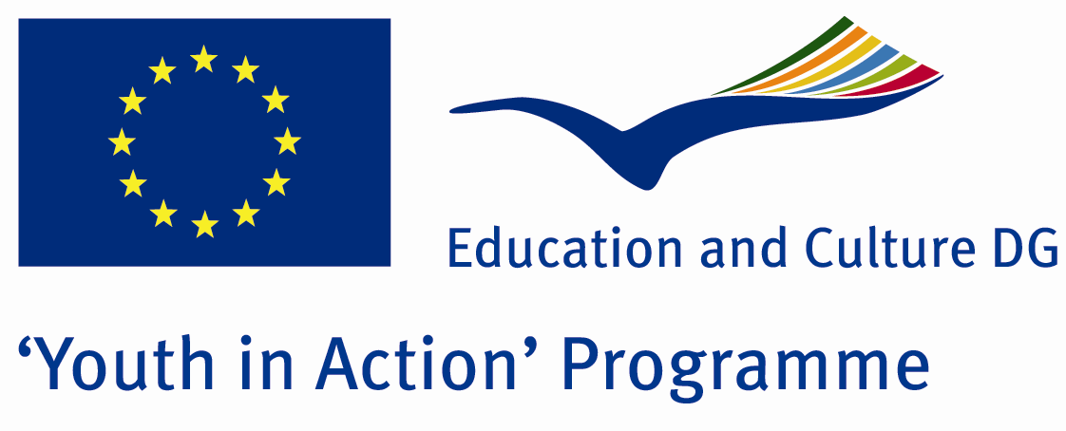

Risk


ACTION 4.3 – Training And Networking

12-18th November , 2011

Hatay , TURKEY

Please contact directly to;
adventurerpeacepigeons@gmail.com

Project Summary;

Our project subject are genetically modified organism and GMO's effects to human health. Most of foods are included the GMO
Which are foods included the GMO? GMO is threaten of human health. our project will provide information about GMO after the our project participants will be more carefull about the food.when they go to shopphing they will pay attention to theme of label. If you want to learn new information about GMO and become to live healthy you can join with us.You won't be regret.If you want to join us, please contact with us…

Project Title; Risk

Date and Venue ; 12-18th November , 2011
Hatay , TURKEY

Target Group ; Municipalities, City Councils and Non-Governmental organizations,
youth groups,culture and art groups,e.t.c

Participants ; 5 people from each country (over 18 -25 ). Totally 8 countries.

Conditions ; Accommodation, board and programme costs will be financed through European Commission Youth in Action Programme ….Travel costs will be reimbursed in 70% (APEX Tarrifs). Organizations from all 27 EU member countries plus Liechtenstein , Norway and Iceland are eligible to take part.

Working language: English

Organizer; Adventurer Peace Pigeons

How to apply: If you are interested, please send your Part III forms to
by e-mail please. (in word file). Scan Part3 format is enough for application. (Fulfilled Part III which you can find in the attachment, of course signed and stamped) ..

Next step 2;
Original send via regular post to this address please:

Ertan DERİN
Fevzi Çakmak Mahallesi Tuncer Sokak No:6 PENDİK/İSTANBUL/TÜRKİYE
e-mail : adventurerpeacepigeons@gmail.com
Mobile : 0090 542 393 93 90

If you have any questions you may contact with: adventurerpeacepigeons@gmail.com

Deadline for application; until 15th 2011.

For Further information:
Contact Person
Ertan DERİN
Fevzi Çakmak Mahallesi Tuncer Sokak No:6 PENDİK/İSTANBUL/TÜRKİYE
e-mail : adventurerpeacepigeons@gmail.com
Mobile : 0090 542 393 93 90

