Dear volunteers and partners,
We are looking for the volunteers to participate in our long term EVS project in Turkey. We will apply on 1st of April. Our project number is: 2007-TR-32
more details you can find on the web site: http://ec.europa.eu/youth/evs/aod/
Our organization is working as Sending, Hosting and Coordinating organization since 2005 and till now we have organized 7 different EVS projects. So we are trying to cooperate with different associations from different countries to give a chance to the youngsters in our society to know about different cultures. In this case we would like to have volunteers from UK, Sweden, Denmark, Malta, Netherlands, Portugal, Ireland, Romania, Slovakia, Slovenia, Hungary, Norway and Estonia.
For the project we have age limit: 18 – 25.
Volunteers from these countries will be welcomed, from the other countries very motivated volunteers will be welcomed to participate in our Project as well.
Some questions for the volunteers:
- Why are you interested in our project and why did you choose exactly our project?
- Do you have some ideas about the personal project, activities in your mind what you could implement during our project? Please specify!
- Why do you want to do voluntary service?
- Are you motivated to learn Turkish?
- How many hours would you like to work per week?
- Do you like to work with the children?
- Do you have any experience working with children? Please specify!
- What do you know about our organization – Gesoged?
- Do you think that you will face any difficulties in order to adjust to the Turkish society and lifestyle?
- What are you expecting from your EVS?
Please send your answers to the questions, CV, Motivation Letter and Your Photo to the following addresses till 16th of March: gamzeadli.gesoged@gmail.com, gesoged@gmail.com
And please when you will send your CV and Motivation Letter (be laconic and write it no more than on one page) indicate the contact details of your Sending Organization.
We will make selection after 16th of March and will inform you.
Thanks in advance for your interest,
Hope to hear from you soon.
Gamze ADLI
EVS Coordinator
GESOGED
Hacıilbey m. Mehmet Akif Ersoy c.
No: 25 10100 Balıkesir/Turkey
t/f: 0090 266 241 3063
mobil: 0090 545 957 44 43
www.gesoged.info

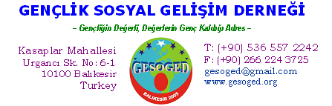

INFO PACK FOR THE YMBF PROJECT
(September 1st 08-August 30th, 10)
Balikesir, Turkey

The project will take place for 12 months starting from 01/09/2010 until 31/08/2011. The first month will be dedicated to an intensive language course and orientation of the volunteer to the environment.
The volunteer will work in a combination of three different environments which consists of: a) kindergartens for pre-school children, b) the university c) the host organization, GESOGED. The biggest proportion of the volunteer’s time will be used in a kindergarten. However, s/he will be asked to spend some portion of his/her time with members of our organization and with socially and economically disadvantaged students of higher education as well. The goal in spending time with the latter is to inform university students about Youth program so that they could widely benefit from that program.
The volunteers will be very welcomed to develop their own projects connected with kindergartens and other activities as well. The same time also Gesoged will propose several activities where volunteer can be involved: writing, organizing new projects in Youth In Action field, organizing intercultural evenings where each representative of his ountry will show up its culture, cuisine, traditions, gathering information and making presentations about educational system in several countries, attending jewelery and painting course to get more familiar with local traditions. There will be also possibility to work on the website, developing it and to create a blog as well.
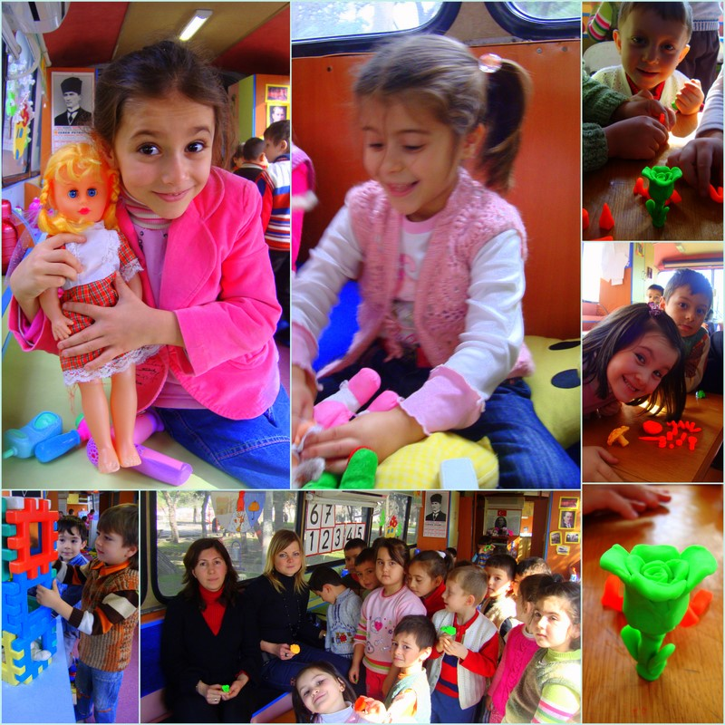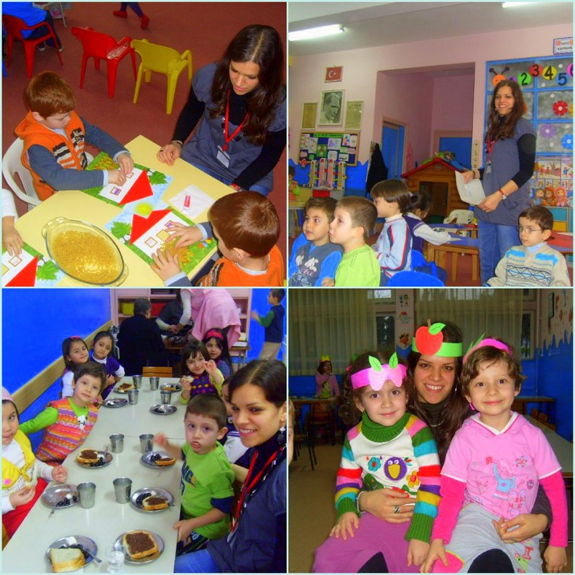

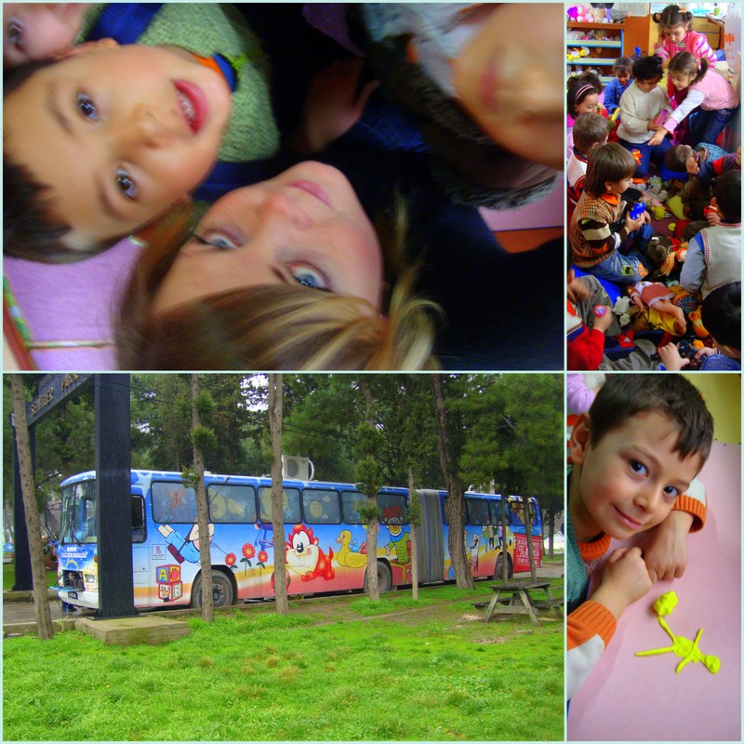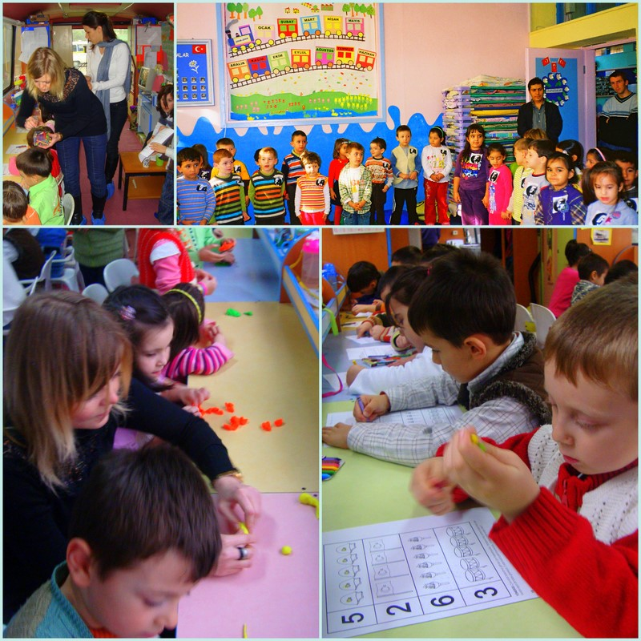
The tasks of the volunteer in terms of the approximate rates of his/her working time in general will be as the following:
- Educational, cultural, artistic, and sportive activities for kindergarten children, who are the main target group of this project: % 55
- Interacting with parents of kindergarten children: % 5
- Participating to the meetings and activities of GESOGED: % 10
- Working for and interacting with disadvantaged or disabled youngsters and kids: % 10
- Working with the project coordinator: %5
- Learning Turkish language and culture: % 10
- Training on youth work and Youth in Action Programme and all other necessary activities: % 5
The volunteer will be working a total of 35 hours/week (language course included). No work is involved at the weekends.

Facilities

The volunteer will share a nice and hygiene apartment flat with other volunteers. S/he may share her room with another volunteer. Electricity, hot water and Internet connection will be available for 24 hours every day. The rent, electricity, water and heating costs of the flat (up to reasonable limits) will be covered by the coordinator organization.
Upon arrival, the volunteer will receive an intensive language course from a private teacher. This language course will be 6 hours in a week and will last 6 months.

The volunteers are expected to:
  - get knowledge and experience on youth work and Youth in Action Programme,
  - use and to develop her skills and capabilities,
  - learn Turkish language and culture,
  - get familiar to Turkish system of higher education,
  - learn about structure and processes of NGO’s in Turkey
  - get opportunities of learning Turkish handcrafts,
  - develop tolerance to cultural diversities,
  - demonstrate samples of games, music, meals, dances etc. from her own culture,
  - get a deeper understanding of the Youth Program of EU and youth work,
In order to gain all those knowledge, skills and attitudes, the volunteers will be:
  - working under, and getting support from, the guidance of professional trainers,
  - encouraged to do small projects of her own,
  - asked to express her ideas and suggestions for the activities of GESOGED,
  - introduced to university students in the region and encouraged to participate in their activities,
  - taught Turkish courses 6 hours in a week,
  - invited to all activities of GESOGED
ARE YOU CAPABLE TO MAKE THIS ALIVE?
About Balikesir:
Balıkesir is a province in midwestern Turkey, having coastlines on both the Sea of Marmara and the Aegean. Its adjacent provinces are Çanakkale to the west, İzmir to the southwest, Manisa to the south, Kütahya to the southeast, and Bursa to the east. The provincial capital is Balıkesir City.
Balıkesir is easily accessible on Turkey's most travelled road, linking the metropolises of İstanbul and İzmir.
Balıkesir province is famous for its olives, thermal spas, and clean beaches, making it an important tourist destination. The province also hosts immense deposits of kaolinite, with some open-pit mines. The Kaz mountains are also threatened with the expansion of gold mining using cyanide which puts the villagers' lives, the agricultural economy, and tourism at risk.
Balıkesir is home to a number of natural attractions, including Kuş Cenneti (bird sanctuary) National Park; the bays of Erdek, Bandırma, and Edremit; Ayvalık's coastal beaches; Şeytan Sofrası, Marmara Islands, Alibey (Cunda) Island; the Erdek and Gönen open-air museums; Pamukçu-Bengi, Balya Dağ, Hisar, Hisarköy (Asarköy), Karağaç (Uyuz), Kepekler hot springs, Dutluca Village mineral springs, and Zeytinli Ada hot springs and mineral water springs.
Among the cultural attractions of Balıkesir are the ruins of Cyzicus and Saraylar on the Sea of Marmara, Deasklaion (near Bandırma/Ereğli), and Antandrus (near Edremit/Altınoluk); Balıkesir's Yıldırım Mosque (Eski Cami), the Zağanos Pasha mosque complex, Clocked Church Mosque and quantity of Ottoman vernacular architecture at Ayvalık, and Alibey Mosque (Çınarlı Cami).
There is also a city museum and a fine arts centre in Balıkesir.
Besides these things there are plenty of other leisure activities:
You can spend time in University with students and join them in some sport activities or feel the vitality in the parks sitting on cosy puffs or grass, playing games, hanging out with your friends, drinking turkish tea or coffee.
You can go to the bars, pubs with life music and caffes, swimming pools. You can enjoy the walks in Old city. It’s really charismatic. You can try turkish cuisine every day in new place. You can play tavla and other traditional games in many caffes. You can go to the turkish bazar and discover turkish lifestyle. You can go to many amazing places what are very close from here.
You can live and enjoy every moment being here.

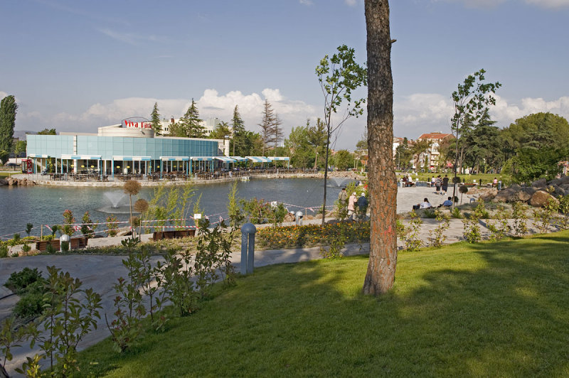
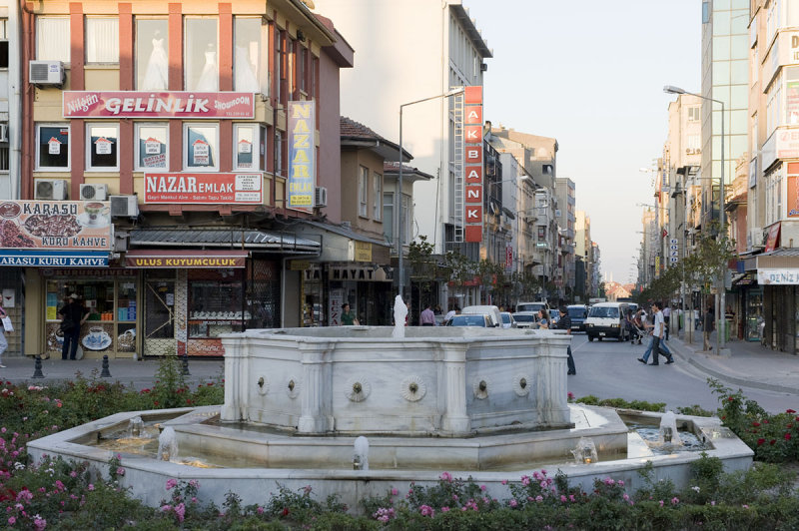
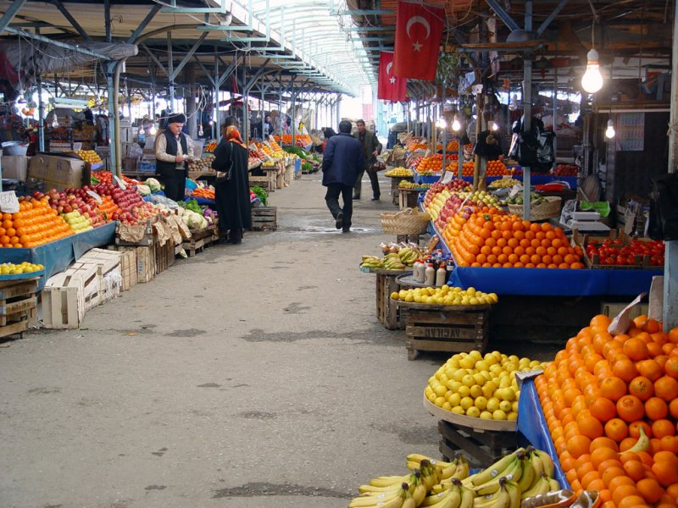
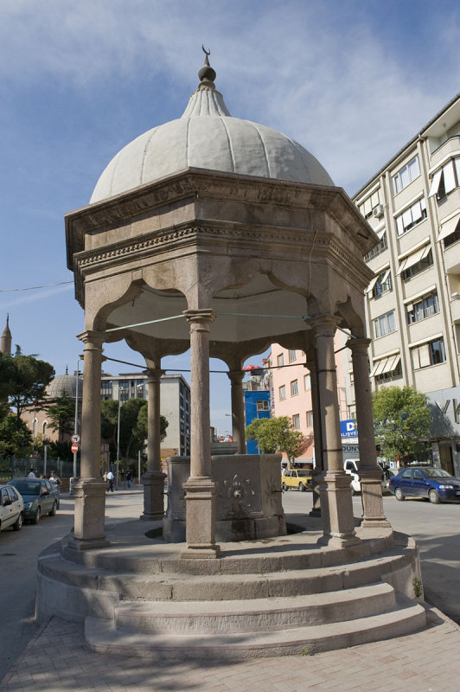
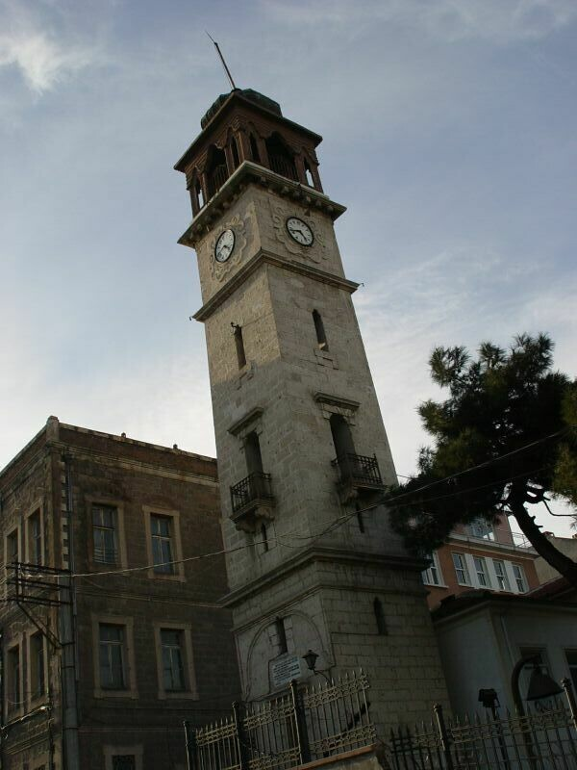

Any questions? Please just ask…

Take care,

Dr. Fahri CAKI
Vise Chairman
GESOGED, Turkey

