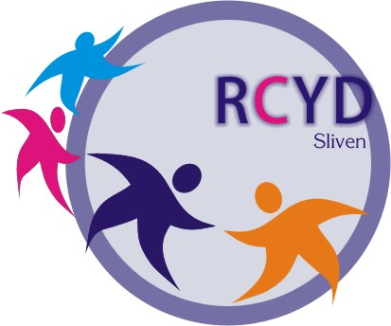

Application Form

“Youth Programs: Ensuring a Quality Future”

Bulgaria, 30 May till 06 June 2010

Organised by: Regional Center for Youth Development

Personal data:

Full name of applicant :
Nationality :
Date of birth :
Sex (underline) : Male / Female

Private address :
Postal Code :
Phone :
Fax :
E-mail :

Name and address of the organization/institution/authority, which supports you:
Organization name :
Address :
Postal Code :
Phone :
Fax :
E-mail :

Organization general aims:

Organization main projects/activities during the last year:

What is your position and job in your organization?

Have you participated in a similar event? When? Where?

What are your expectations about the training?

How do you think this event will benefit you and your organization?

How could you contribute to the training?

Special needs (some assistance, vegetarian food etc.)

( ) vegetarian
( ) special diet – (please specify):
( ) other remarks concerning meals:

English (working language): ( ) fluent ( ) good ( ) basic

Travelling:

Please explore and describe the cheapest mean of transport and travel costs from your location to Thessaloniki’s Airport return (student fare, APEX tickets, etc)

Means of transport (underline) : airplane - bus - train
Estimated price (in Euro) :
Expected arrival time :
Expected departure time :

In case you need a visa for entering Greece, please write your personal data:

Surname :
Name :
Date of birth :
Sex :
Nationality :
Place of birth :
City and region of residence :
Passport number :
Date of issue :
Date of expiry :

Name and full contact details of next-of-kin to be contacted in case of emergency:

Name :
Address :
Postal Code :
Phone :
E-mail :

Signature of applicant

Date: Place: Signature:

Only completely filled applications will be accepted.

Please send your completed application form (by e-mail) until 23 January 2010 to:
youth_center@abv.bg

