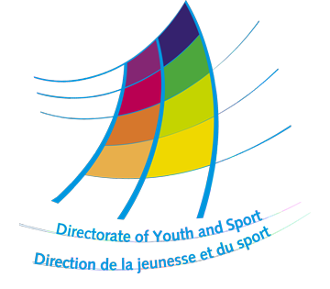
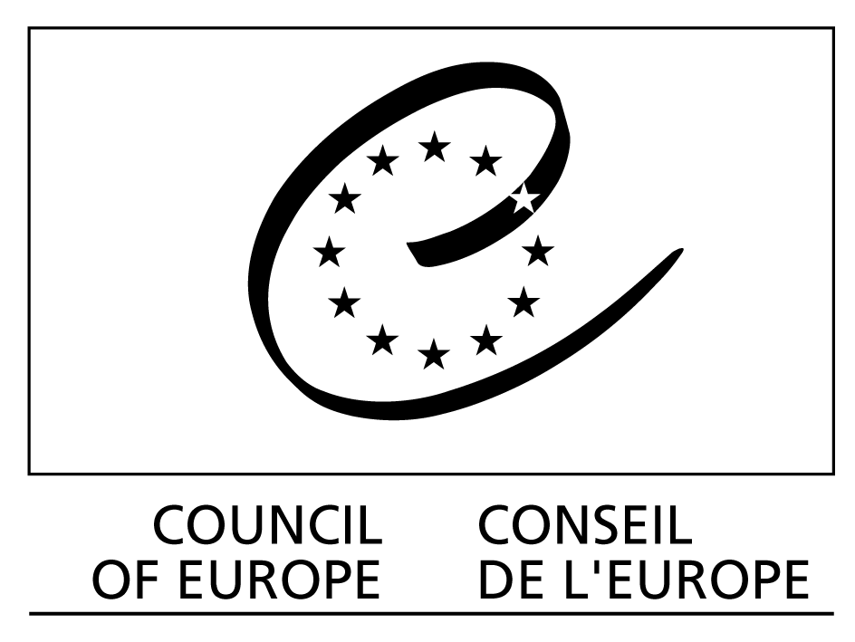

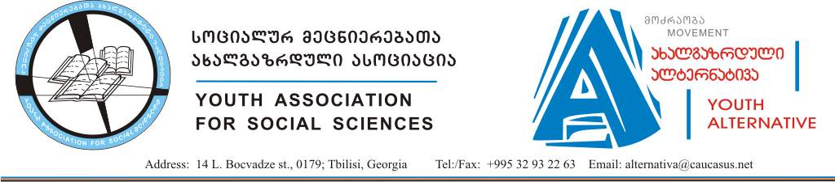

Youth immigrants and IDPs
Inclusion activities as a tool for conflict prevention

Tbilisi, Georgia

Arrival date: 19/06/2009
Departure date: 24/06/2009
Youth immigrants and IDPs
Inclusion activities as a tool for conflict prevention

After the Russian-Georgian war the formation of new groups of IDPs created new problems in social life of Georgia. A problem of migration and IDP’s is actual for several COE countries. Among IDPs the most vulnerable groups are children and youth. Their full social integration would be an important step on the way to decrease the risk of new conflicts. On example of Georgia, Inclusion of these groups would deprive politicians of an argument saying that their right to return is a reason to re-take Abkhazia and South Ossetia by force. The same risk exists in other post-conflict regions in the remaining countries of Southern Caucasus, and Moldova. In order to decrease this risk, sharing the experience of inclusion activities is needed. It can be provided by NGOs from countries with significant migrant groups as Austria, Germany. Better social cohesion and inclusion of young people – one of the priorities of COE in youth sector – may be achieved this way.

Main themes of the meeting are:
Migrants in post-conflict situation;
Migration policy in Europe;
Youth IDPs’ and migrants inclusion mechanisms

Objectives of the meeting are:
To identify main problems of the migrant and IDP Youth and find ways of their resolution;
Promote cooperation among European youth and work out common vision on migrant/IDP policy;
Share an experience of successful and unsuccessful inclusion activities;
Work out youth inclusion mechanisms of migrant/IDP youth; Develop understanding and cooperation among different nations;

Methodology: The training provides a transparent learning process on migration and IDP issues. We create environment for personal and professional development of the participants. Considering recommendations given in Compass and T-Kit, the trainers use methods of non-formal education during the meeting: Icebreakers; workshops; Teambuilding activities; Working in the small and larger groups; Intercultural learning, intercultural evening.
During the 4-day meeting, participants will work on preparing a joint project on IDP problems.
• Presentations about organizations
• Share experience in the field of migration, IDPs and peace building
During meeting participants will: • Working in small groups • Workshops • Lecture of guest speaker.

Target Group: Youth NGOs, young leaders, youth workers. Age between 18 and 25.

Working Languages: English and Russian.

All candidates must apply using the enclosed application form. This form should be sent directly to the email address of Organizer no later than May 22, 2009.

The results will be announced after May 25, 2009. Only successful candidates will be contacted.

Technical Information

Accommodation
Board and lodging will be provided by organizers for the whole duration of the meeting in Georgia.

Insurance
Participants are asked to have their own insurance for the duration of the Forum for accident, civil liability or illness. The organizers do not cover insurance costs.

Financial Information

Travel reimbursement
Travel costs of all participants will be reimbursed partially (70%) based on the original tickets, invoices and all travel related tickets.

Visa costs of foreign participants will be reimbursed by the organizers.

Due to a low budget for transport, we encourage participants that come from a range of 1000 km to use bus or train as means of transport.

Before purchasing your tickets, please consult with the organizers upon the travel costs.

We kindly ask you to use any alternative possibilities of funding that can cover travel costs. Sometimes your sending organizations or structures would effort to cover the travel costs or you may identify small local grants to contribute for the travel cost. We would appreciate very much your help.

The maximal reimbursements of travel costs for the participants are:

Moldova - 315 Euro
Russia - 350 Euro
Austria – 280 Euro
Armenia – 25 Euro
Azerbaijan – 30 Euro
Germany – 280 Euro
Serbia – 400 Euro

Participation fee: 30 Euro

Eligible countries:

Moldova, Russian Federation, Austria, Armenia, Azerbaijan, Germany, Serbia, Georgia.

Age: 18-25

Application procedure and deadline

Please use the application form enclosed to this mail. Applications forms must be e-mailed to the organiser, to this email address: info@alt.ge

By May 22, 2009 at the latest
Good luck!

APPLICATION FORM

Please type or use CAPITAL letters and write legibly. If necessary, please attach an extra sheet.

First Name  [as on your passport] |  |  | Family Name  [as on your passport]
Nationality |  | Date of Birth |  | Gender | Female  Male
Complete address
Postal code |  | Town |  | Country
Phone (including mobile phone)  [with full international dial codes] |  |  | Fax  [with full international dial codes]
Email |  |  | Website
Language(s) abilities: Please mention all languages in which you are able to work and indicate your level for each of it (N-none, B-basic, G-good, VG-very good, F-fluent, MT-mother tongue)
 | Listening | Speaking | Reading | Writing
English
Russian
Other languages:
[please specify]
Do you have any special needs or requirements that the host organization should know about? (E.g. mobility, medical needs, allergies, dietary restrictions, smoker/non-smoker)

Your organization:
Name
Complete address
Postal code |  | Town |  | Country
Phone  [with full international dial codes] |  |  | Fax  [with full international dial codes]
Email |  |  | Website
Activity level | local regional national international

Please describe briefly your organization
What is the mission and objectives of your organization?
Please describe your role in the organization.
What are your functions (youth worker, board member, youth leader ...) and your tasks?
In what way are you involved (professional or voluntarily, full or part-time)?

Have you applied for, or attended, any other event financed by EYF in the past? (If yes, which one(s) and when?):

Motivation and Expectations:
What is your motivation to take part in expected meeting?

What is your and your organisations’/institution’s involvement in the migration and IDP issues?

What do you expect from the meeting?

Please give the following travel details:

Estimated travel cost (in EURO):
Mean of travelling (bus, train, plane):
Arrival date and time:
Departure date and time:

Your date of birth: Passport No.: Issued at (place):

Issued on (date): Date of expiry:

______________________________________________________________________
Applications form must be sent to e-mail: info@alt.ge

By May 22, 2009 at the latest

Date: Signature:

