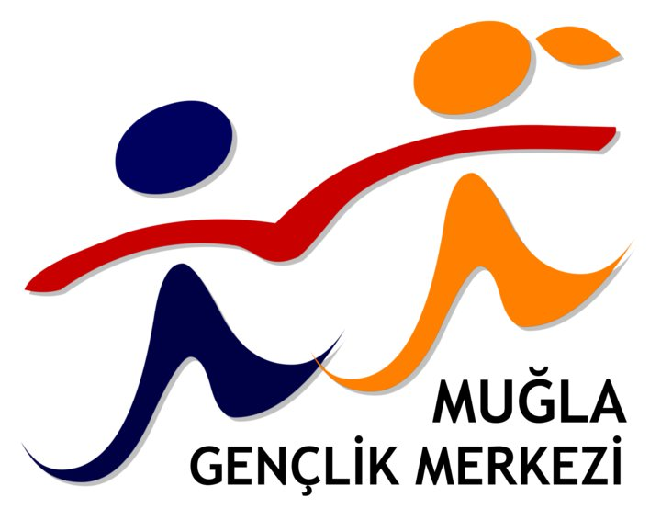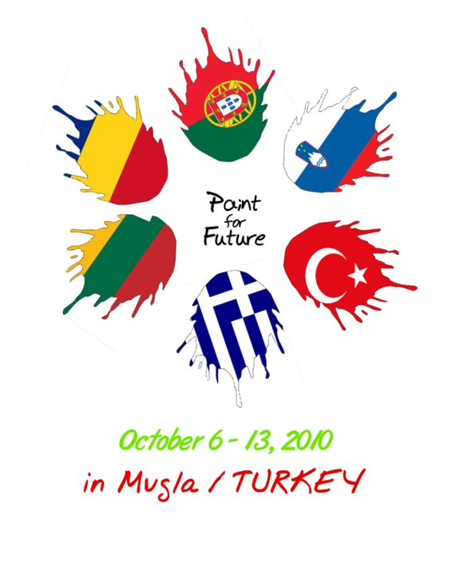
Action 1.1 Youth Exchange – Paint For Future
Mugla - TURKEY
A European Training with the support of the EU Youth Programme. Organised by Mugla Youth Centre

Arrival Day: 06/10/10
Departure Day: 13/10/10
All the national teams is necessary to fill this form till September 15.

Table 1: NGO Data
Official Name of NGO
Full Address (street, post code, city)
Phone (with international – local code)
Legal Responsible person
Fax (with international – local code)
Email

Table 2: Group Leader Data
Full Name
Date of Birth / Age
Sex
Phone (with international – local code)
Mobile Phone (with international – local code)
Personal Email
Passport No or. ID No.
Health 2
Diary 3

Table 3: Group Data
Full Name | Date of Birth | Age 1 | Sex | Mobile Phone | Passport No or ID No | Health 2 | Diary 3
(1) Participants age have to be between 18-25.
(2) Fill with Good, Other: please describe.
(3) Fill with All ok, Vegetarian, Other: please describe.

Table 4: Transfer Data
City (start place)
Airport Name (from this airport start the air trip to Mugla)
City –> Airport (Please explain how you go to Airport? Cost in Euro per person?)

